Introduction

The purpose of this document is to assist new groups in setting up the project. It covers launching the project, moving the project to your own GitHub, setting up an Azure environment and altering credentials.

Contents

1. GitHub Image Repository 3

1.1 SonarCloud 4

1.2 Authenticating to GitHub 4

2. Setting up Azure 5

2.1 Requirements 5

2.2 Creating an application in Azure 6

2.3 Creating App Roles 9

2.4 Exposing APIs 10

2.5 Create a Management Admin user. 13

2.6 Setting Redirect URIs 17

2.7 Retrieving IDs 19

3. Modifying Environment Variables 22

3.1 Service Variables 22

3.2 Dashboard Variables 23

4. Creating an Organisation Within Azure 24

4.1 Creating Users for The New Organisation 28

4.2 Grant Permissions 33

# GitHub Image Repository

To run the entire project, the repository named SWSP-Infrastructure is used. By running docker compose up the project will pull all the relevant images from GitHub and start the docker containers in the correct order.

For this to work, you require access to your own set of repositories. We recommend creating a new GitHub organisation and copying the repositories as follows.

1. Create a folder for all the repositories.
2. Git clone [repo]
3. Cd [repo]
4. Git remote rm origin
5. Create a GitHub repository for the branch
6. Git remote add origin [new repo link]
7. Git push -u origin main*

*Note that for some branches you might need to Git push -u origin master* instead.

After pushing the projects to their respective repositories, the images can be found under Packagesas shown below.

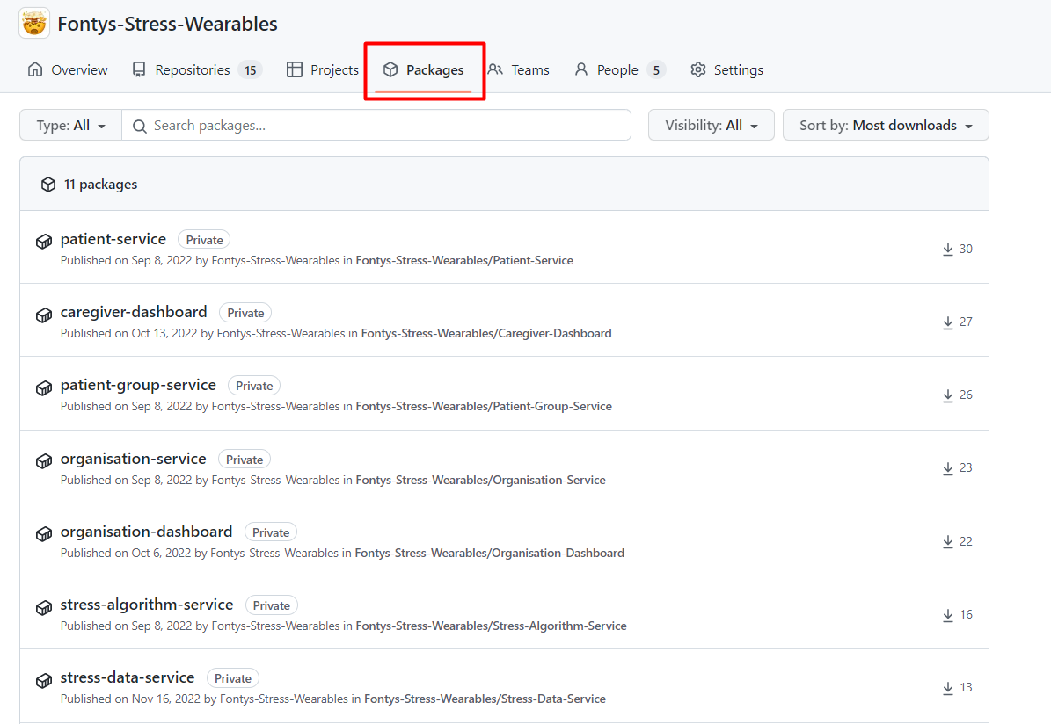

This is necessary for the following repositories:

* SWSP Infrastructure
* Caregiver Dashboard
* Organisation Dashboard
* User Service
* Feedback Service
* Stress Data Service
* Organisation Service
* Patient Service
* Patient Group Service
* Stress Algorithm Service

After the GitHub repositories have been removed, the references in the docker-compose.yml of the SWSP Infrastructure project should be adjusted. For example, under patient-group-service the image should reference your own repository image.

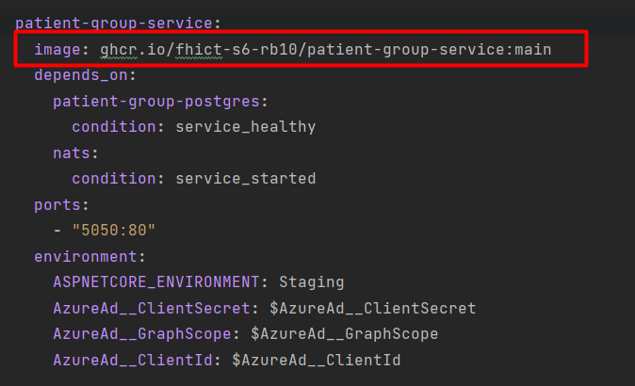

Don’t forget to push these changes for the rest of your group!

## SonarCloud

For the images to be created successfully, it may be necessary to set up SonarCloud.

Currently the project is under a Fontys student account from one of the group members. In the case sonar cloud fails for not being able to run sonar cloud because of misfunctions of the account not being available a new account will have to be made.

You can use the [Getting Started Documentation](https://docs.sonarcloud.io/getting-started/github/#:~:text=If%20your%20code%20is%20on,in%20using%20your%20GitHub%20credentials.) from Sonar Cloud to change accounts.

## Authenticating to GitHub

To run the docker compose file successfully, you must authenticate your docker client against GitHub to grant it access to the package registry.

First, generate a Personal Access Token by clicking on your profile picture in the top right when in GitHub, going to "settings", then to "developer settings" and then "Personal Access Tokens". Here you can create a new token and specify what rights it should give. Make sure that "packages:read" at least is checked and then generate the token.

Now, make sure Docker desktop is running and then open your CLI of choice and enter:

docker login ghcr.io -u YOURUSERNAMEHERE --password YOURPERSONALACCESSTOKENHERE

You should now be able to run Docker compose up in the infrastructure folder and pull all packages from the package registry.

# Setting up Azure

Authentication and authorization are handled by Azure Active Directory. To run the project, this environment needs to be set up. The instructions below and directed at setting up Azure using a Fontys account but should apply to any Azure environment.

## Requirements

1. Your favourite IDE.
2. Docker.
   * For windows: <https://docs.docker.com/desktop/windows/install/>
   * For mac: https://docs.docker.com/desktop/mac/install/
3. Access to an Azure environment: <https://portal.azure.com/#home>

## Creating an application in Azure

1. [Create a Tenant – Microsoft Azure](https://portal.azure.com/#view/Microsoft_AAD_IAM/CreateDirectoryBlade/releaseCreateOperation~/false).  
   *Note that if you do not have an existing tenant within Fontys’ Azure environment, it will not let you navigate to Active Directory to create one. Therefor, it is recommended to use this direct link.*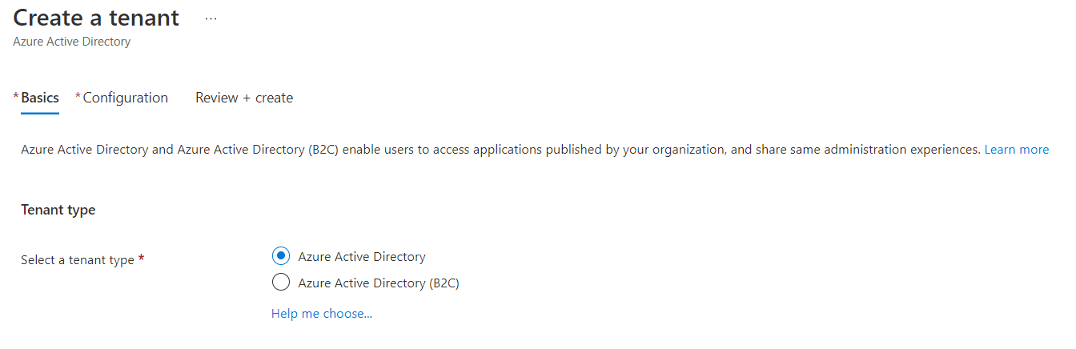
2. Set Configuration  
     
   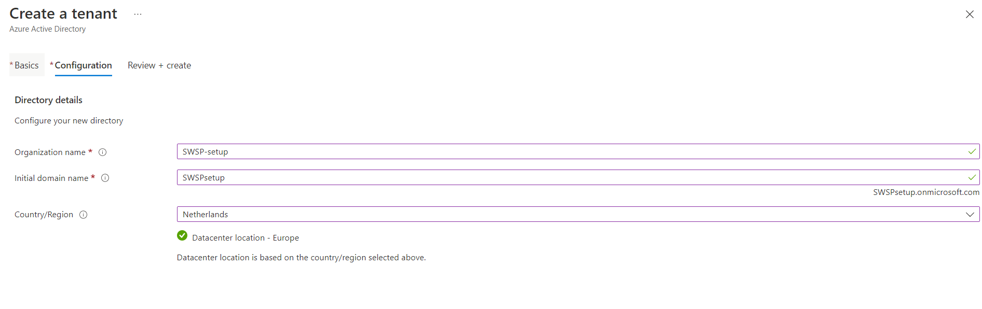
3. Create the Tenant and prove that you’re not a robot.   
   This will take a few minutes to complete.  
     
   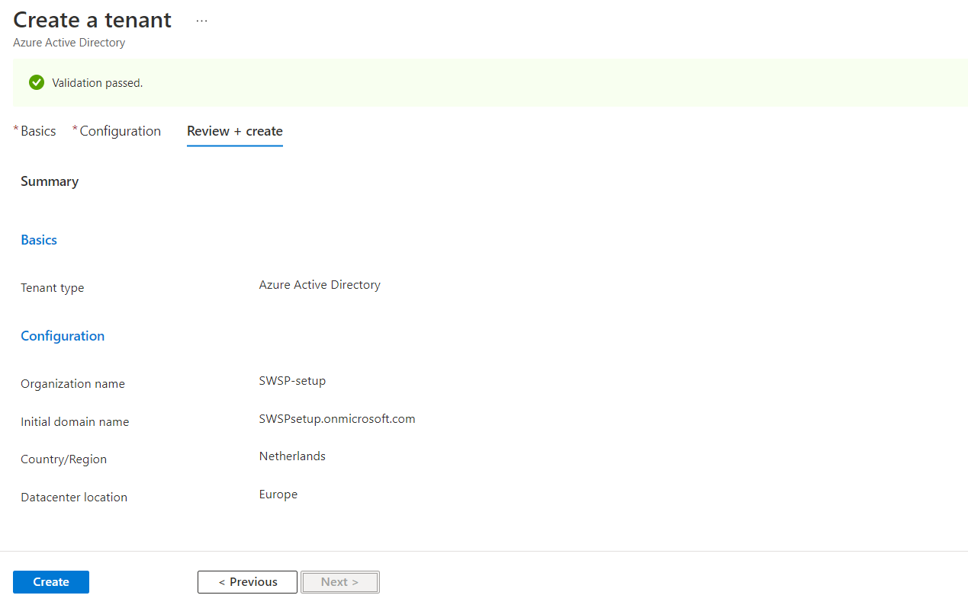
4. After the process is complete, you have an option to switch to the new tenant. Alternatively, you can look at your directories using the settings symbol and switch to your newly created tenant.

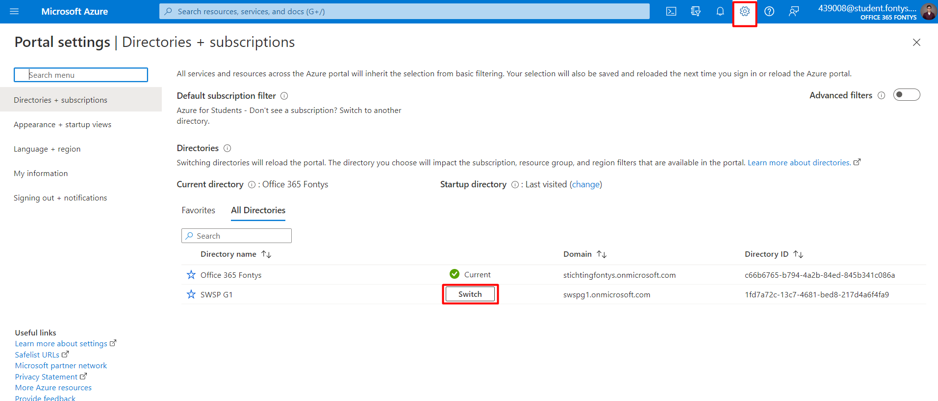

1. Navigate to Azure Active Directory  
     
   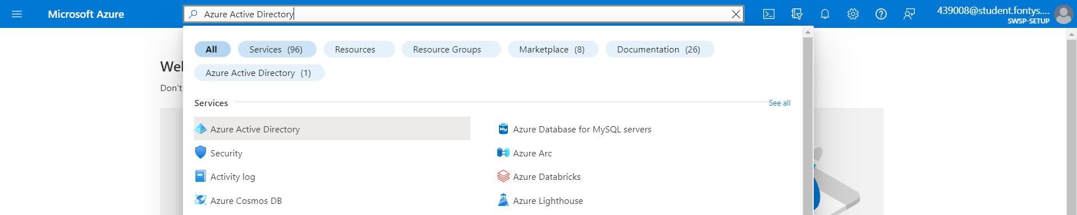
2. Navigate to App registrations.  
     
   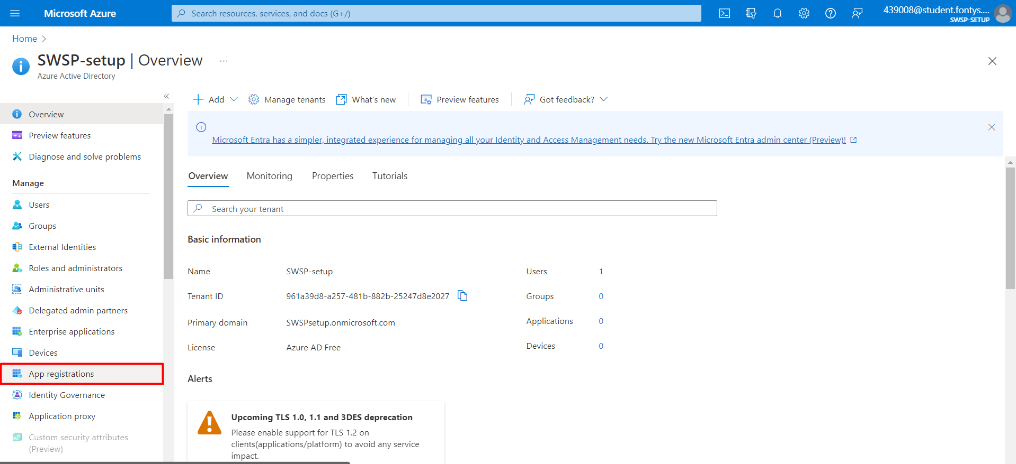
3. Add a New Registration.  
     
   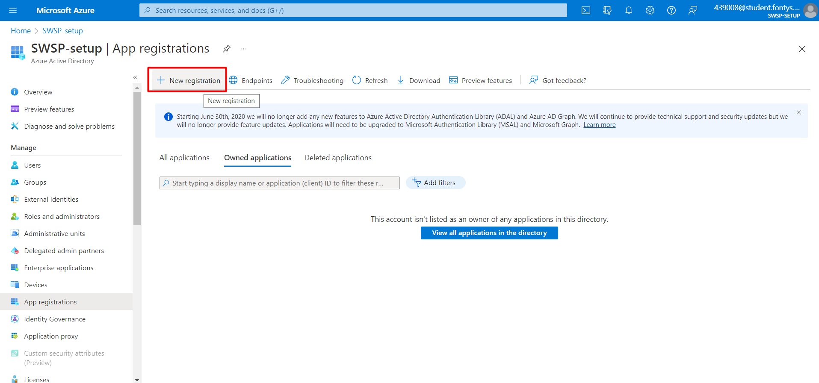
4. Register the application.  
   *Note: Ensure the info in the red boxes is set properly. The redirect URI is “http://localhost:3030/organizations”*  
     
   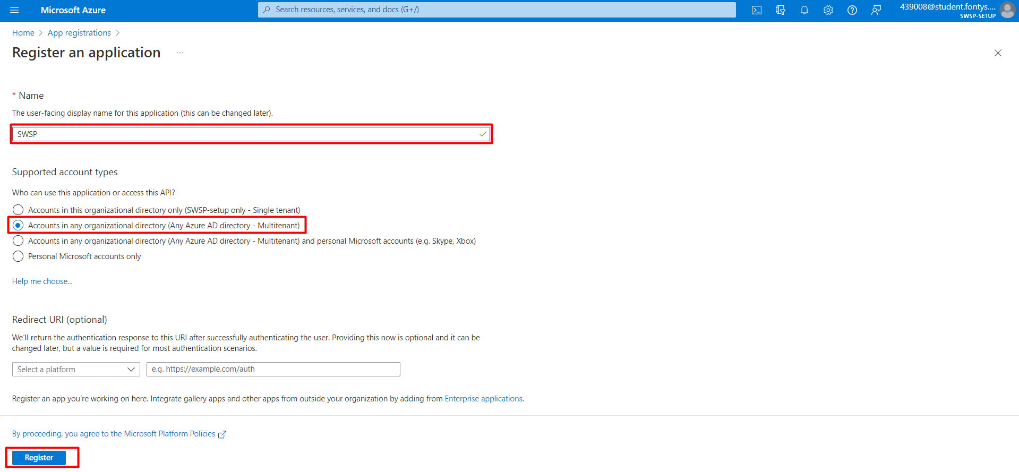
5. If everything went well, this is the result.  
   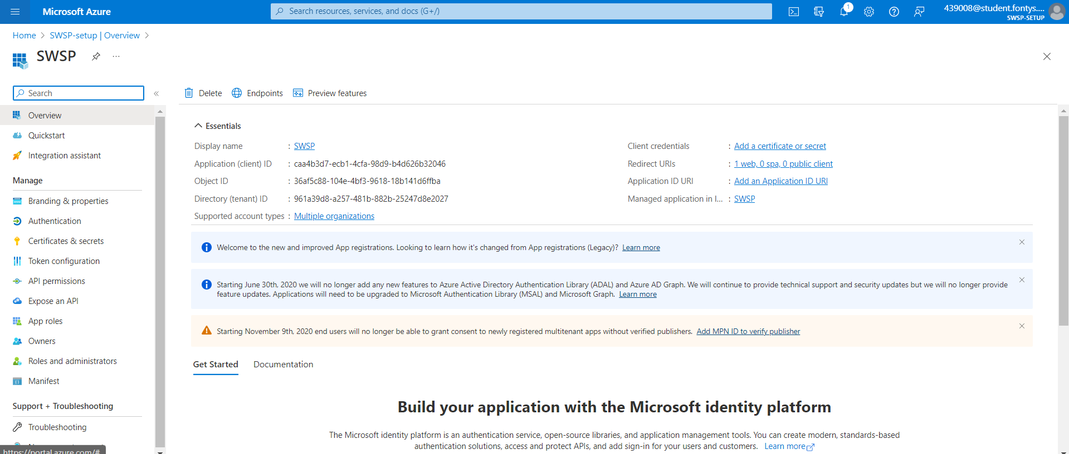

## Creating App Roles

1. Navigate to App roles.  
     
   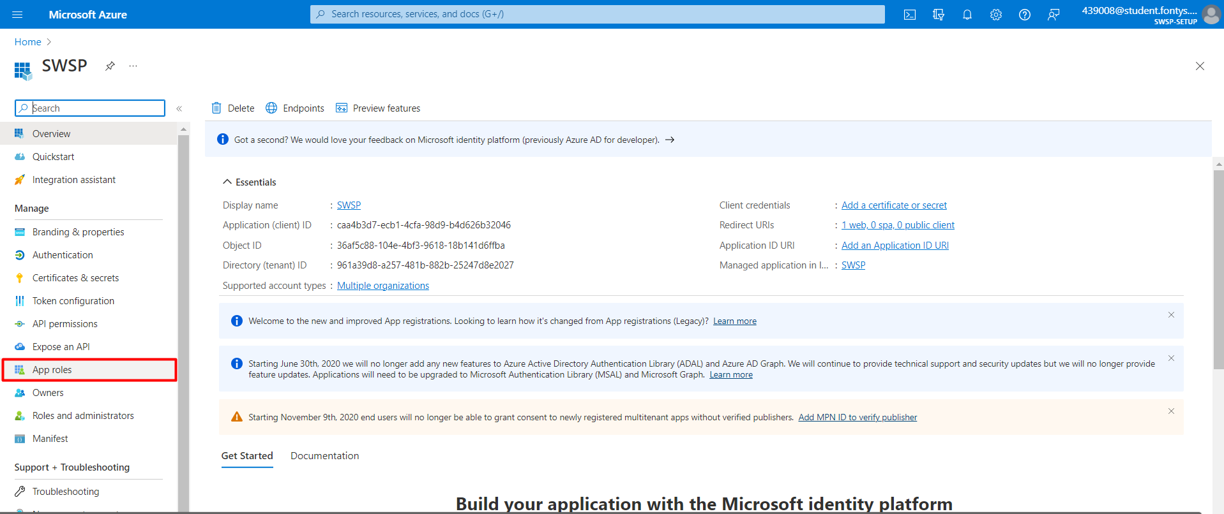
2. Create the caregiver role.  
   *Note: It is especially important that the Organization.Caregiver value is spelled correctly.*  
     
   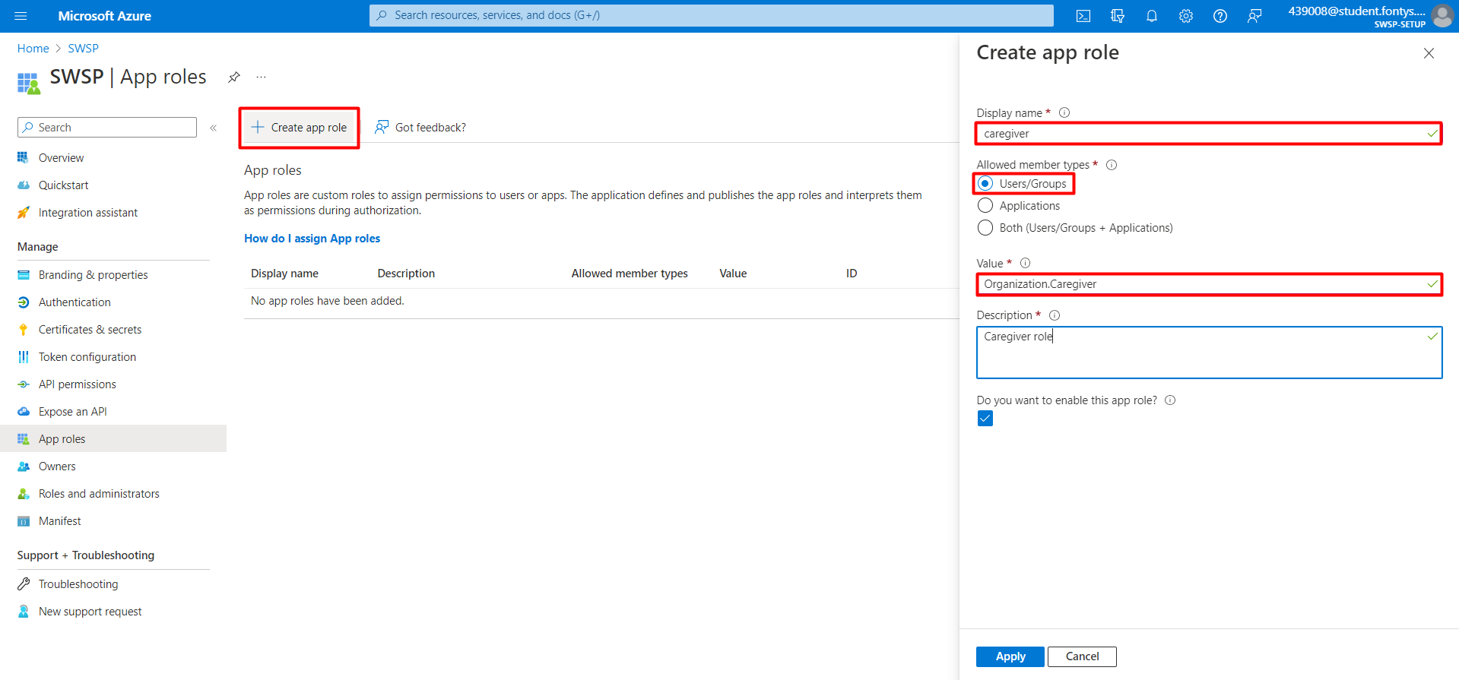
3. Create the organization role.  
   *Note: It is especially important that the Organization.Admin value is spelled correctly.*  
   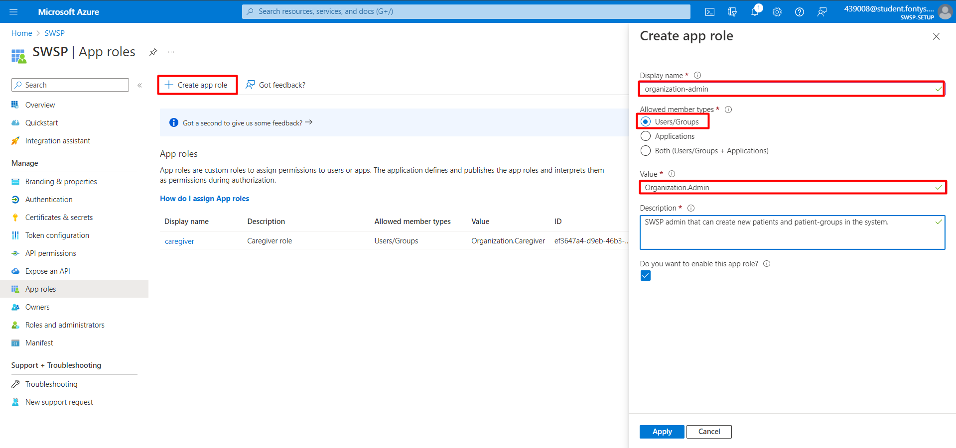
4. If everything went well, this is the result.  
     
   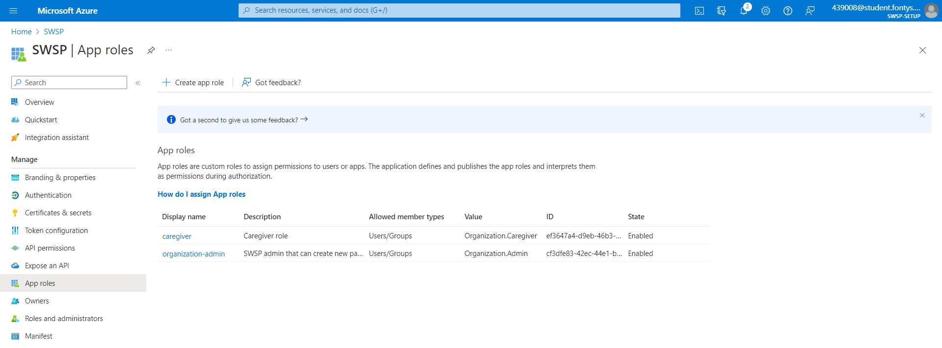

## Exposing APIs

1. Navigate to Expose an API.  
     
   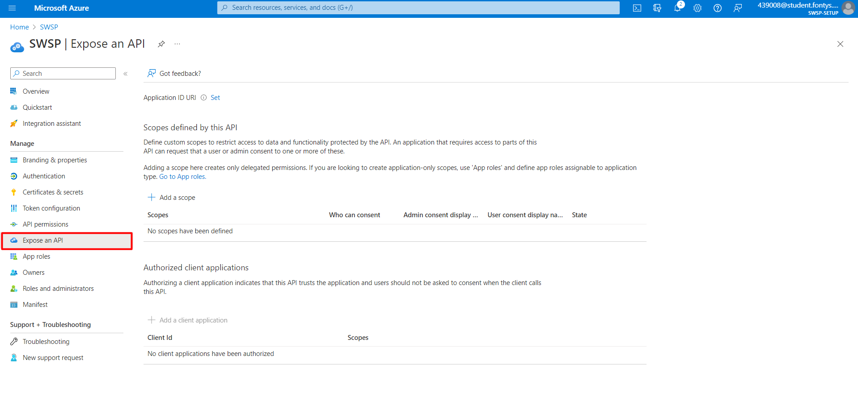
2. Add a new Scope.   
   *Note: The Application ID URI will automatically be filled in.*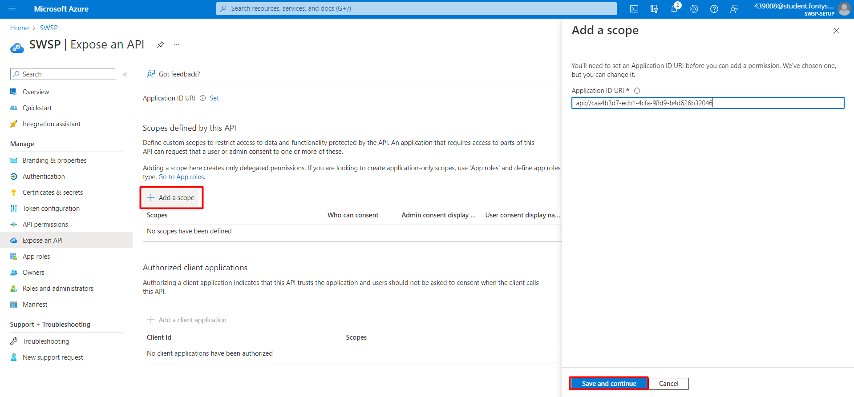
3. Add a scope named “ ”.   
     
   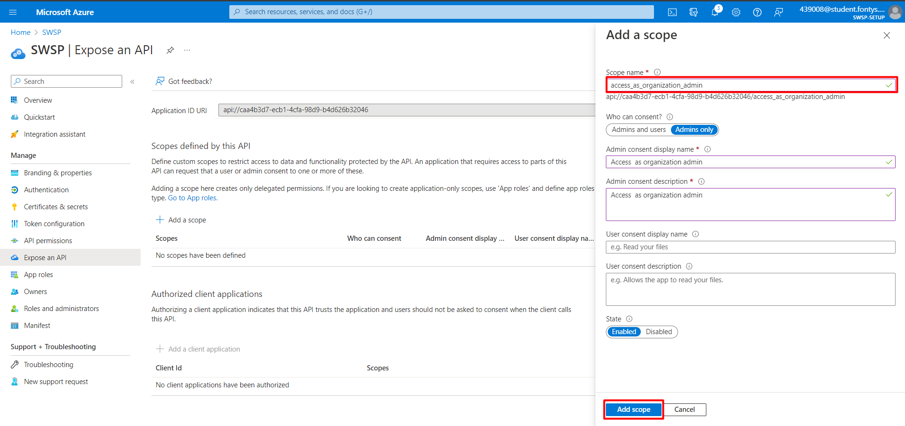
4. Add a scope named “access_as_caregiver”.  
   *Note: Ensure “Who can consent?” is set to “Admins and users”.*  
     
   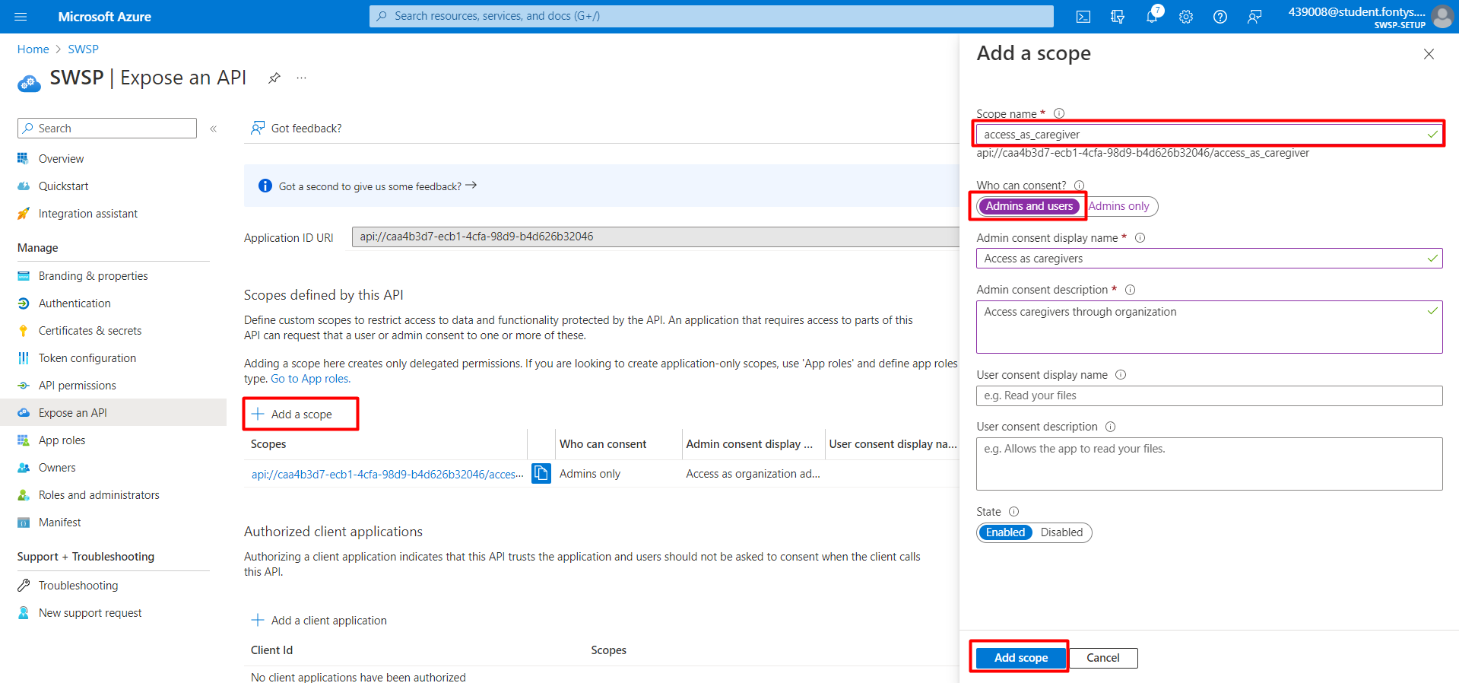
5. Navigate to API permissions.  
     
   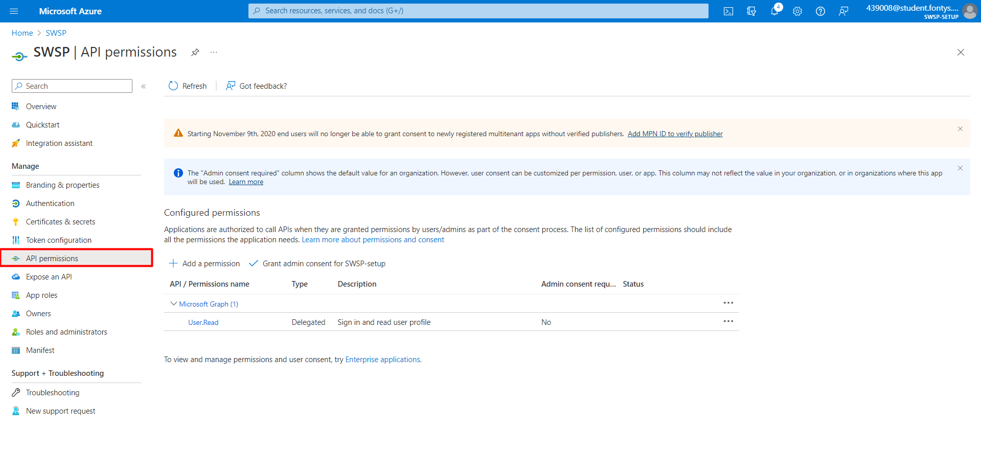
6. Add a permission, navigate to My APIs and select SWSP.  
     
   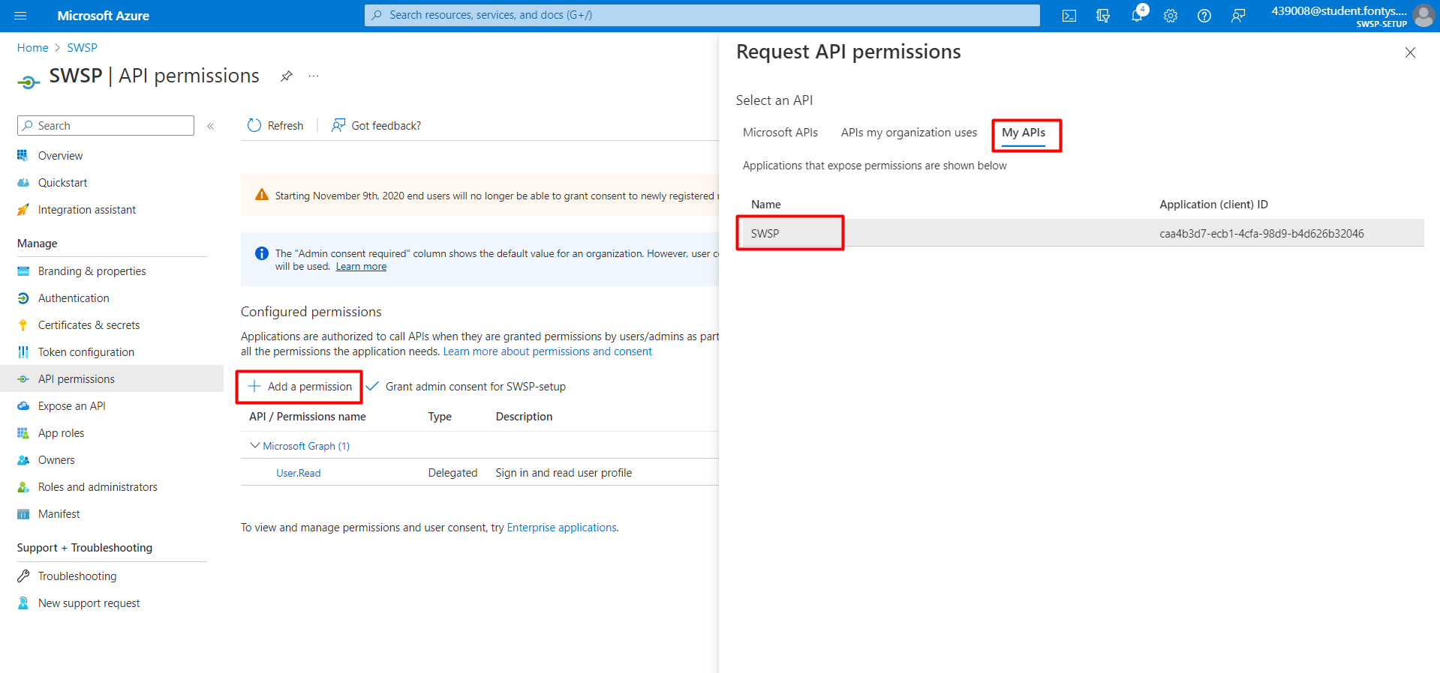
7. Select both permissions, then click Add permissions.  
     
   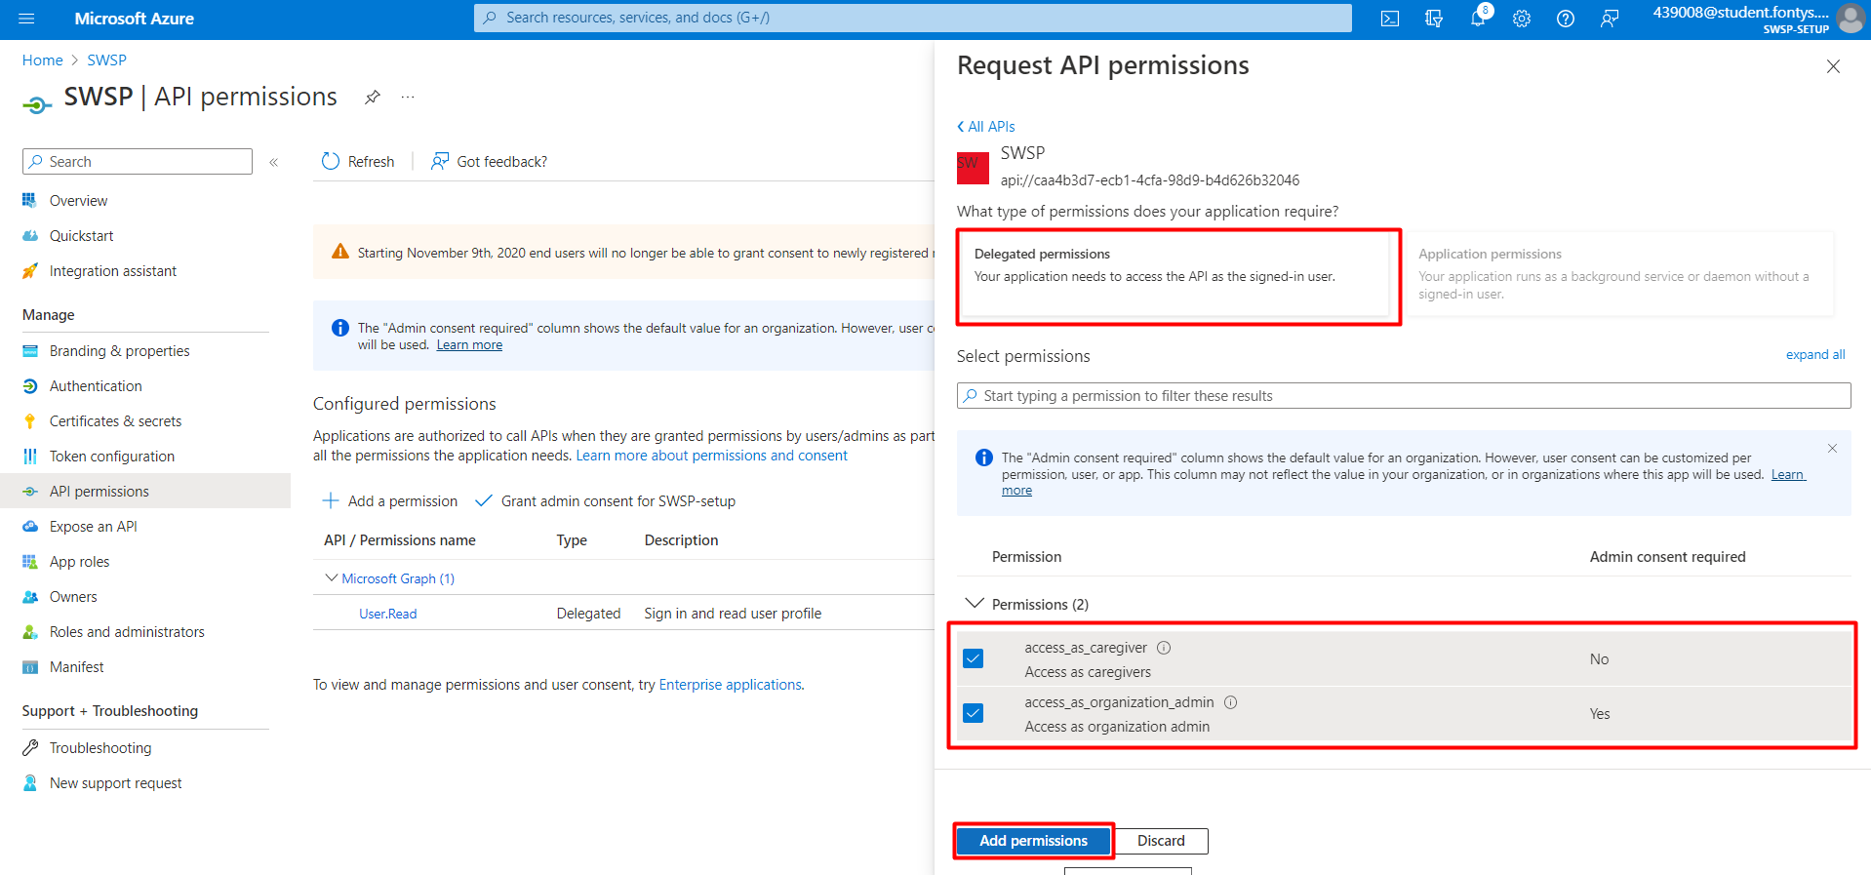
8. Grant admin consent and confirm.  
     
   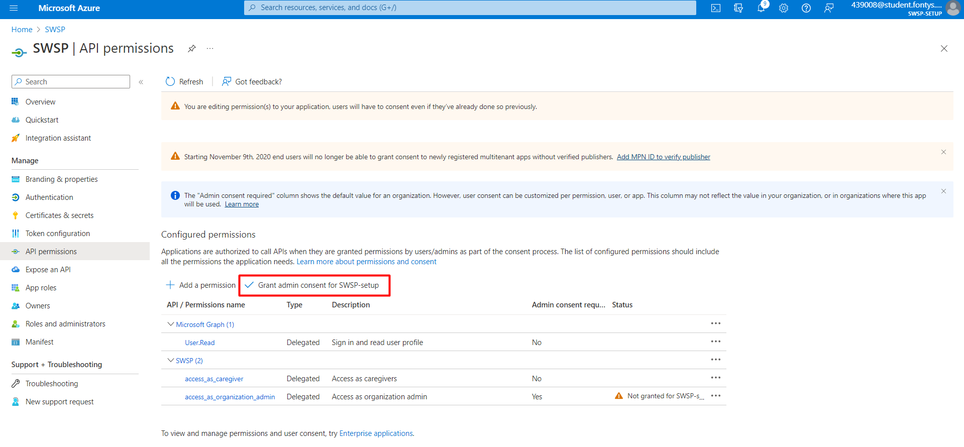
9. If everything went well, this is the result.  
     
   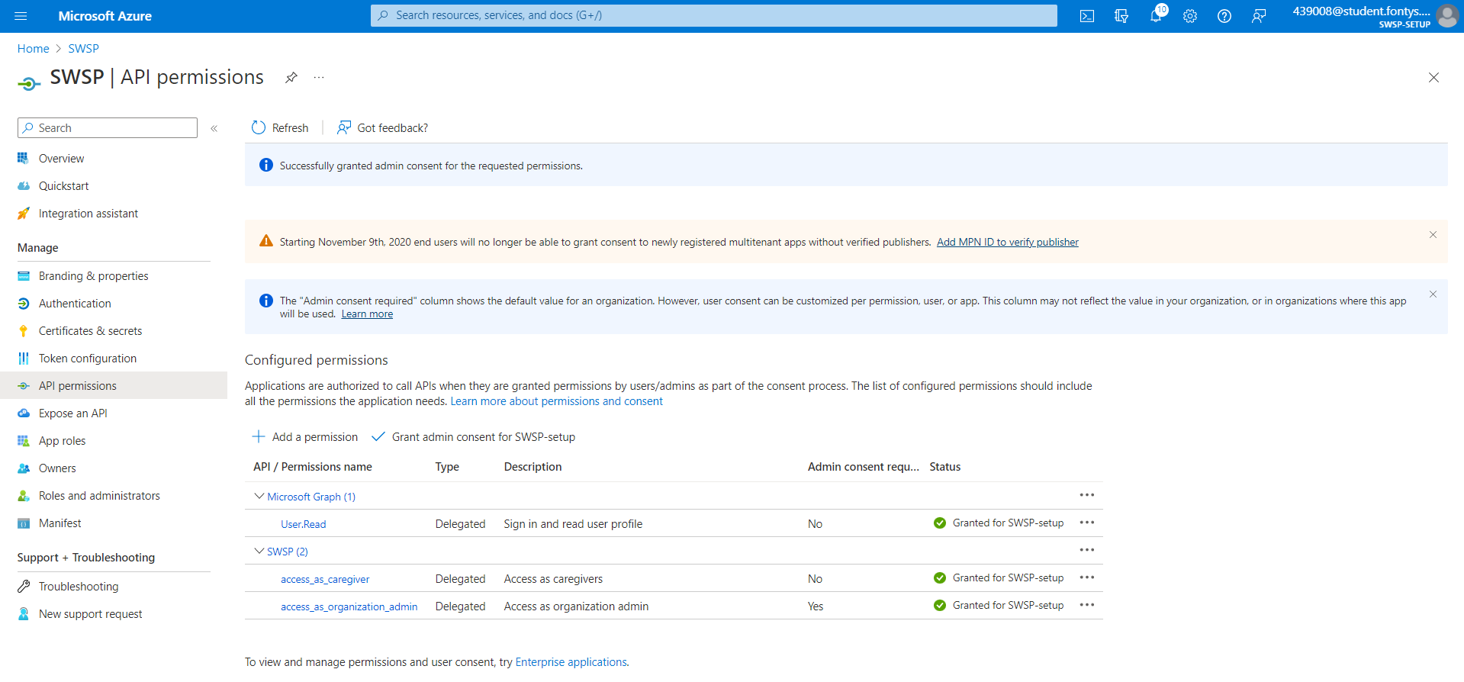

## Create a Management Admin user.

The Management Admin account will be used to add organizations to the app using the organisation dashboard.

1. Navigate to the Users tab.  
     
   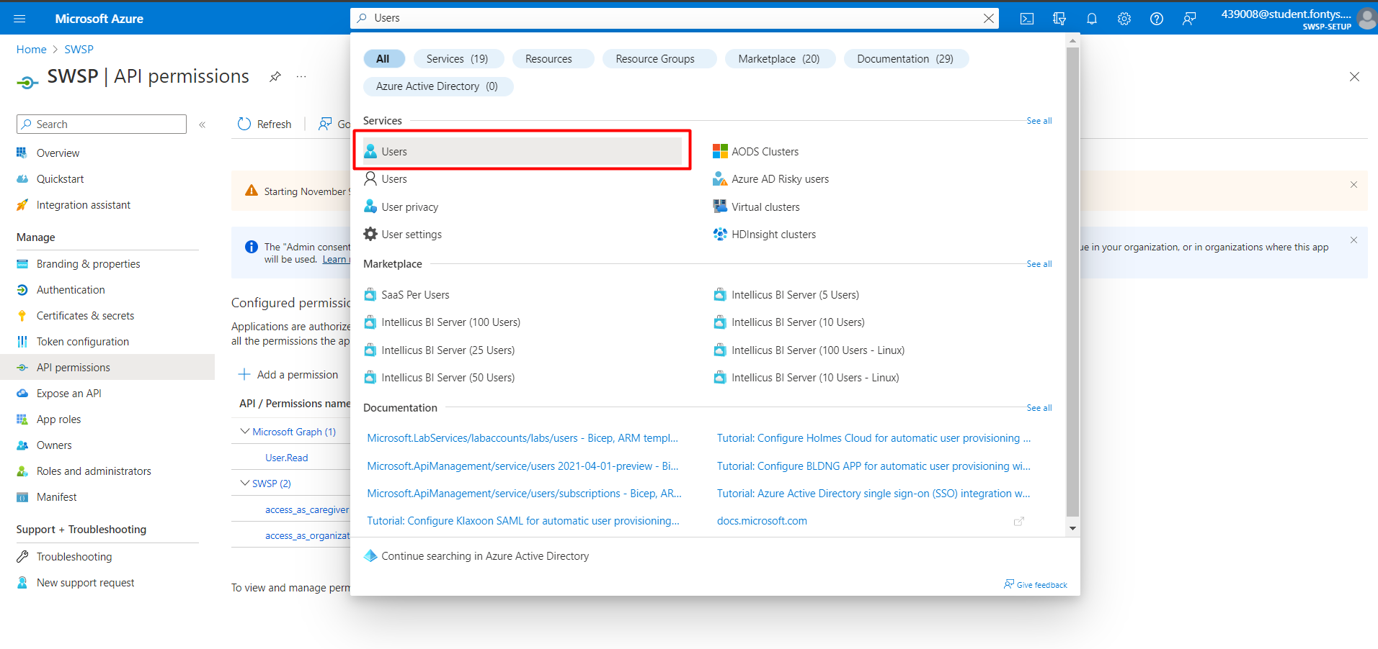
2. Create a new user.  
     
   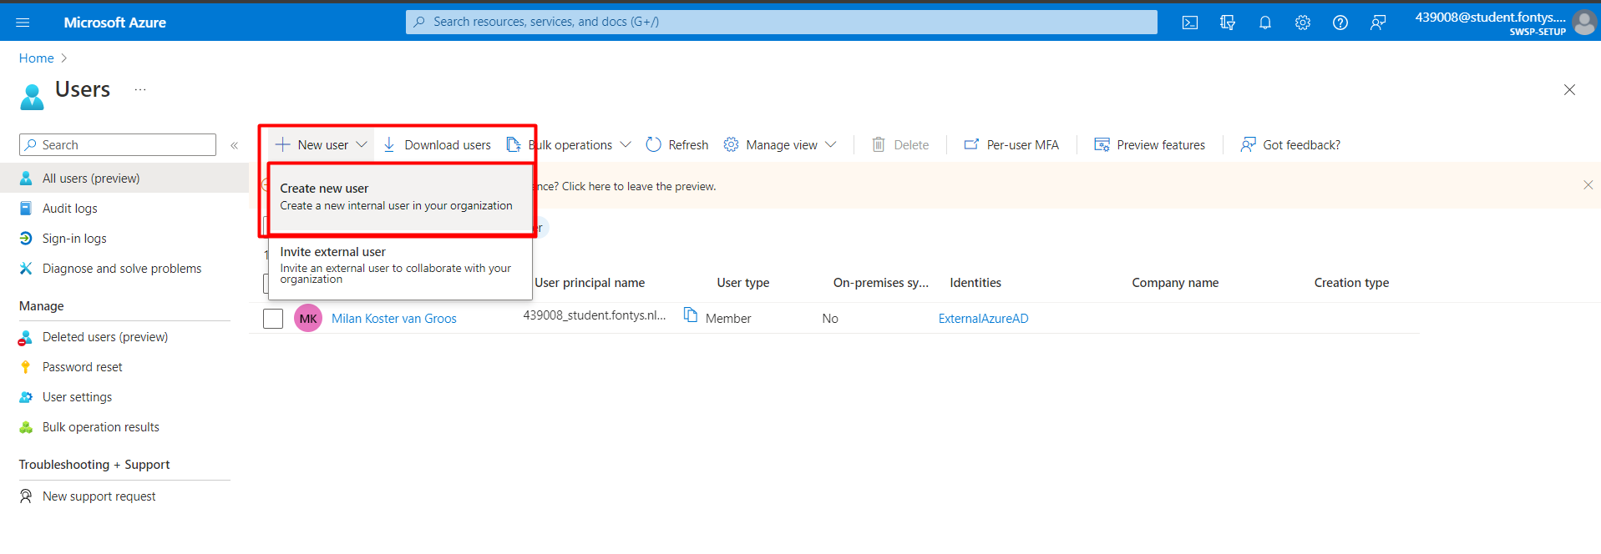
3. Set the username and write down both the username and password.  
     
   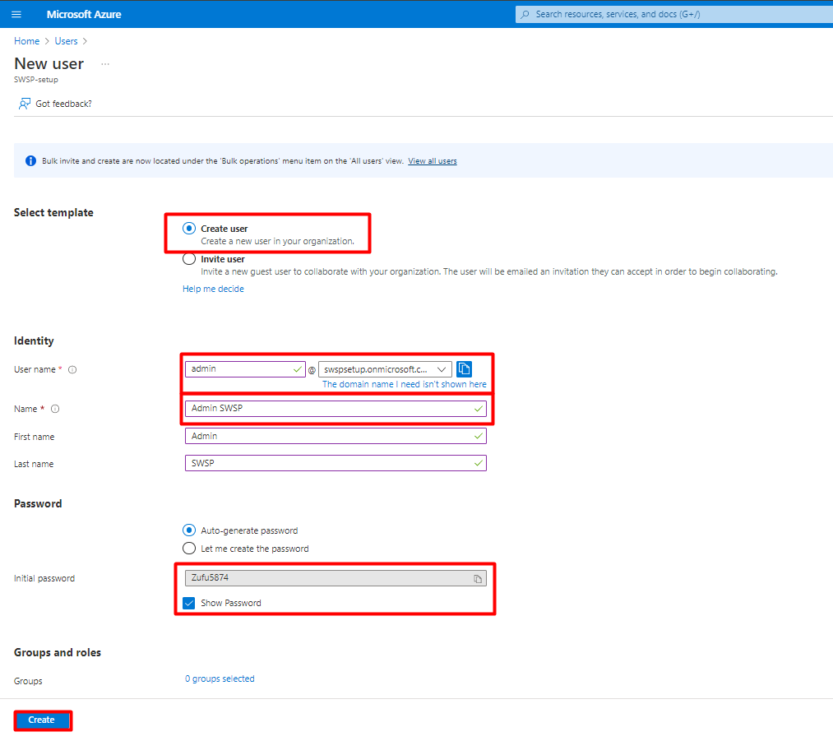
4. Navigate to Enterprise applications.  
     
   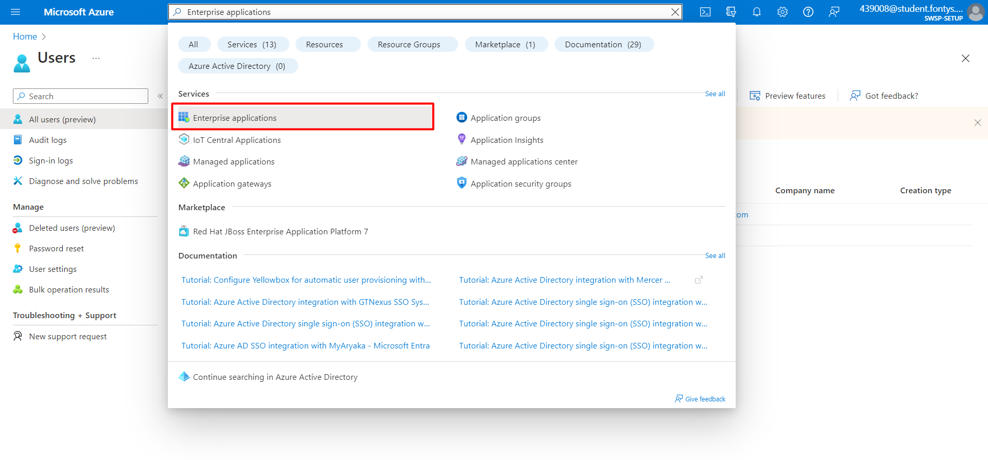
5. Select the created app SWSP.  
     
   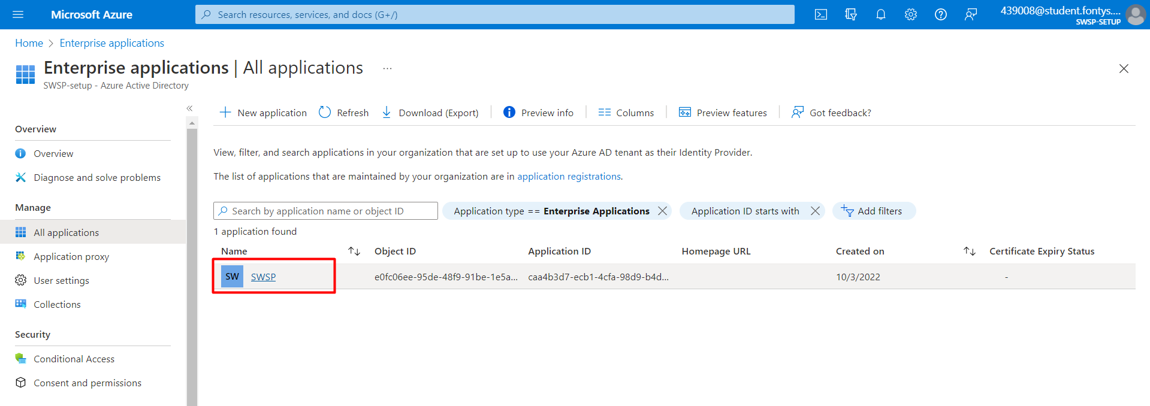
6. Assign users and groups  
     
   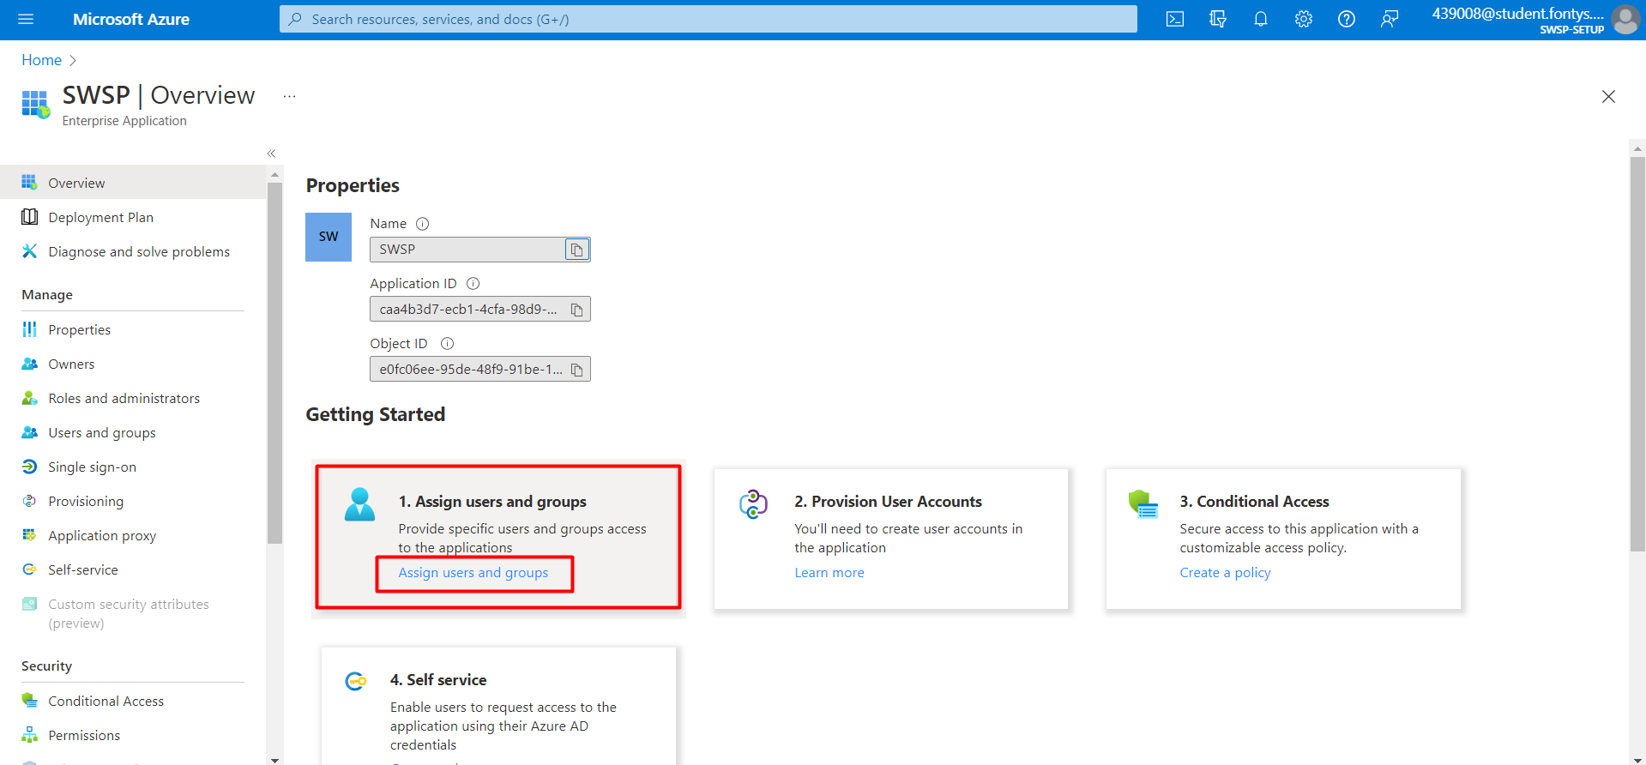
7. Add user/group  
     
   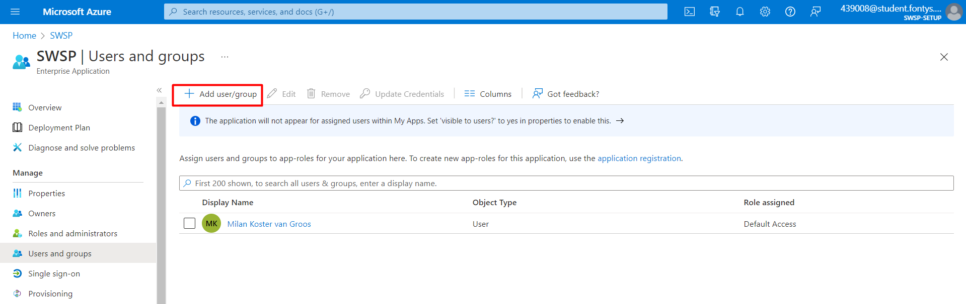
8. Select Admin SWSP and the organization-admin role then click Assign.  
     
   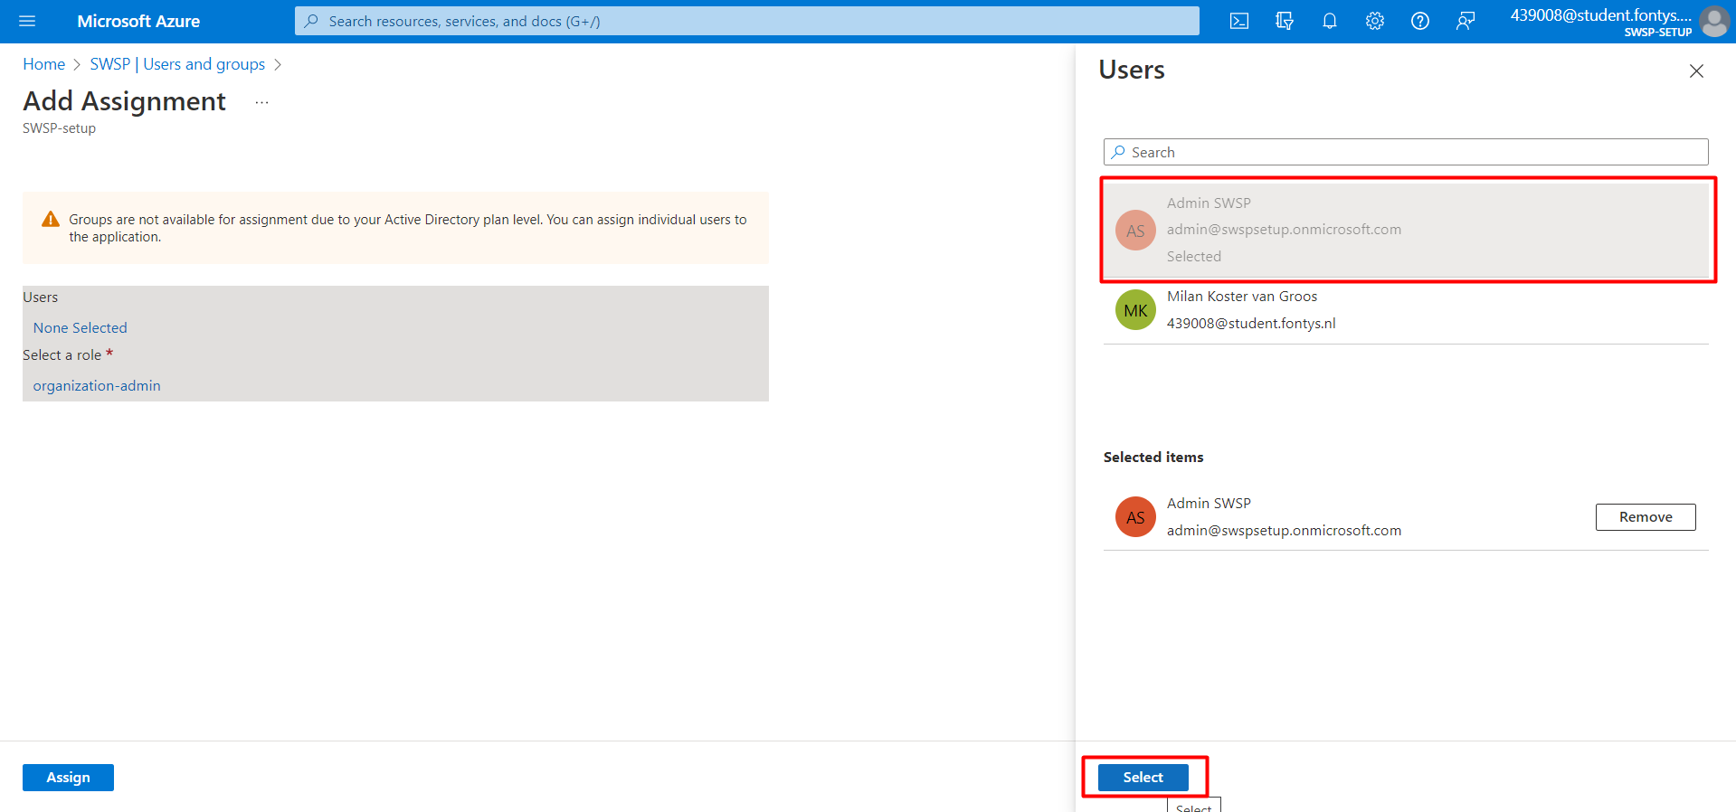  
     
     
   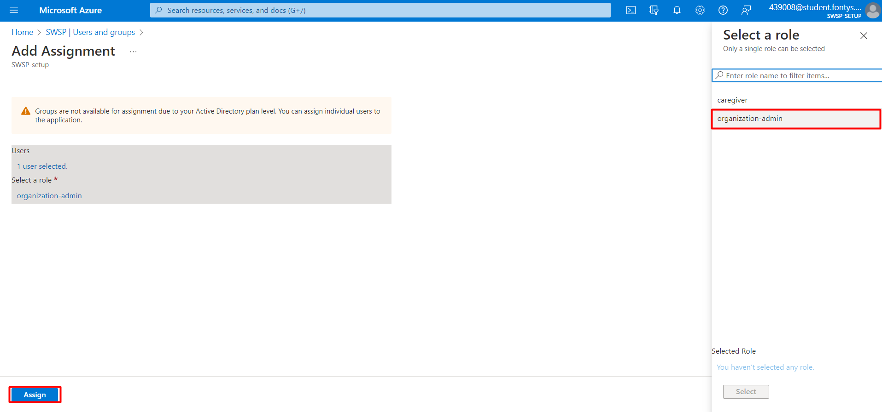
9. If everything went well, this is the result.  
     
   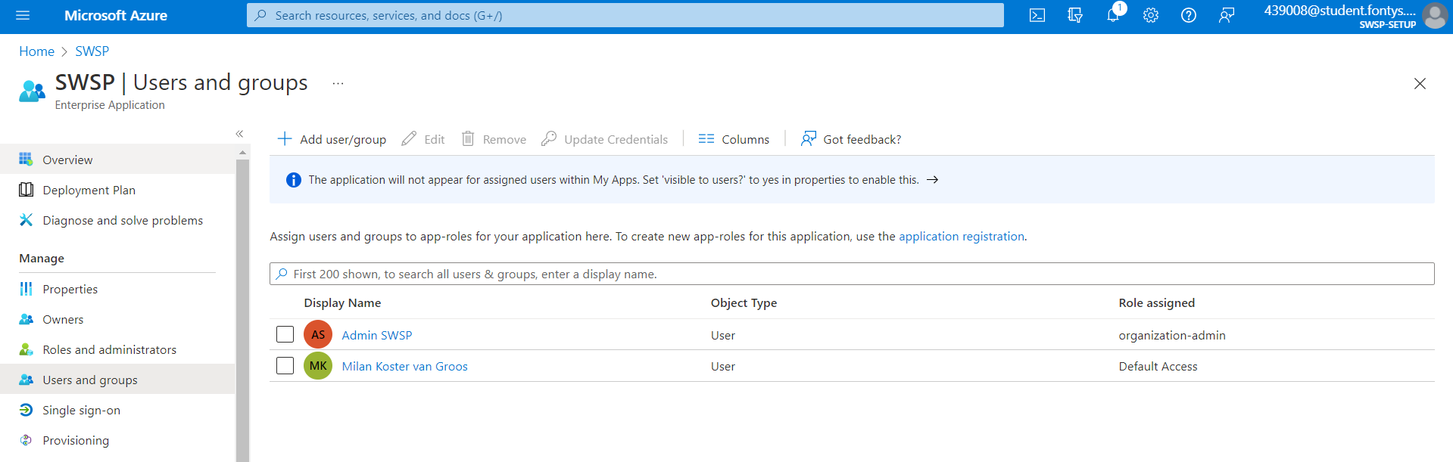

## Setting Redirect URIs

1. Navigate to App Registrations.  
     
   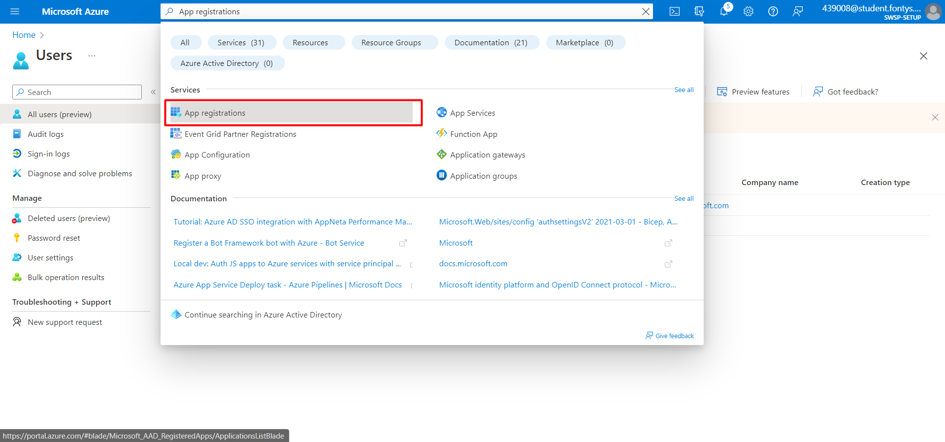
2. Navigate to SWSP.  
     
   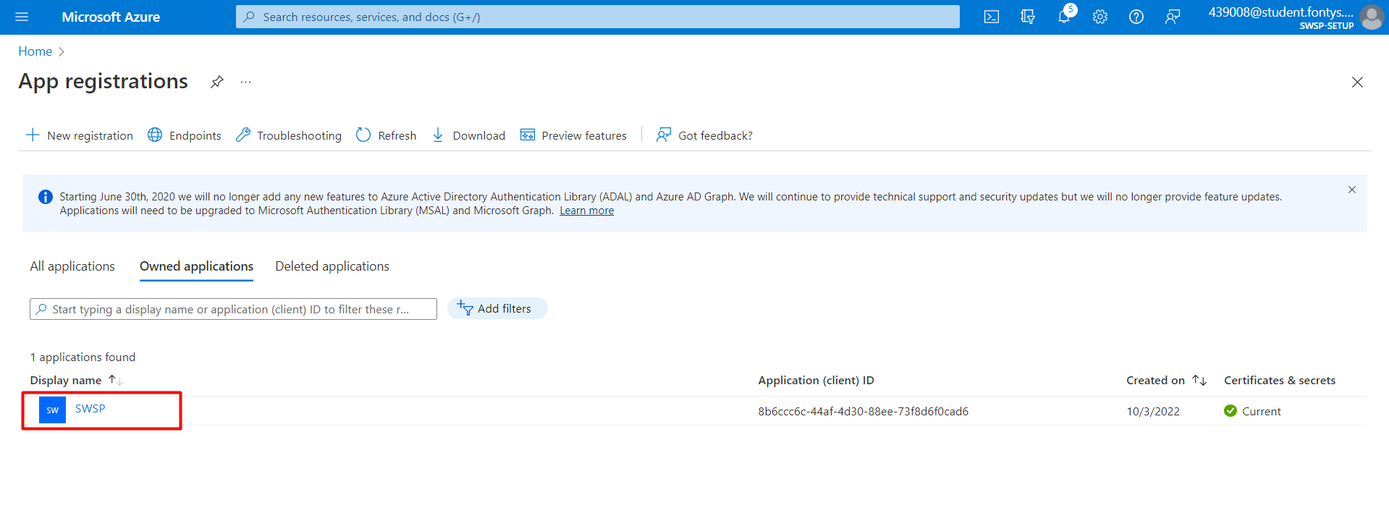
3. Navigate to Manifest.  
     
   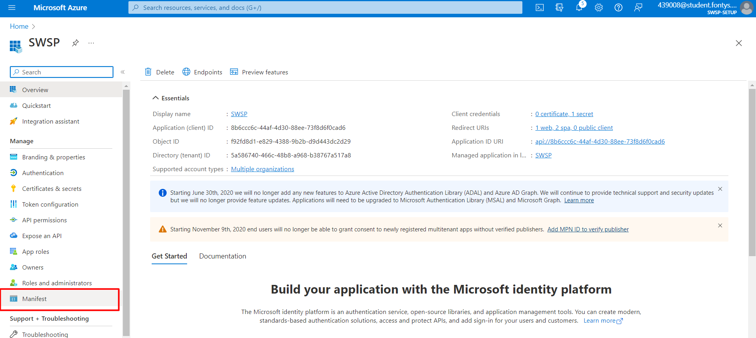
4. Look for “ReplyUrlsWithType”  
     
   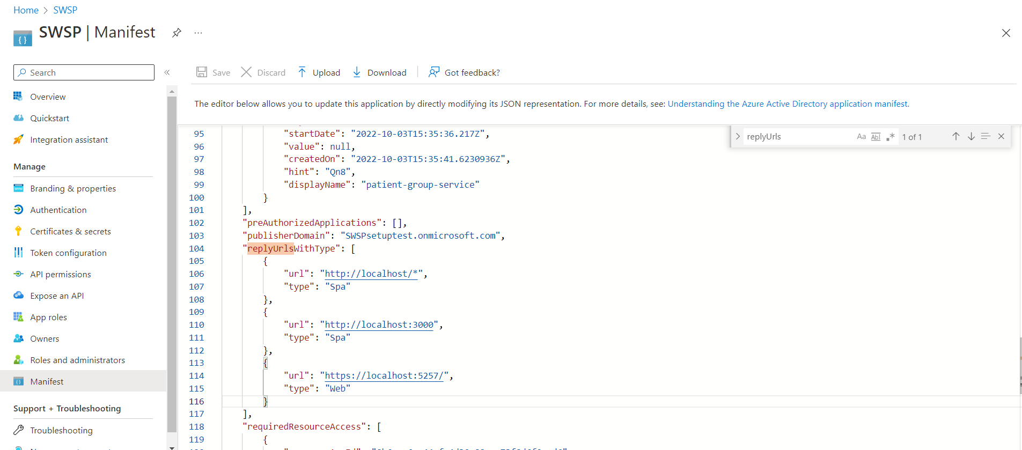
5. Replace it with the following value.

"replyUrlsWithType": [

{

"url":"https://localhost:5257/",

"type": "Web"

},

{

"url": "<http://localhost:3000>",

"type": "Spa"

},

{

"url": "[http://localhost/*](http://localhost/*)",

"type": "Spa"

}

],

## Retrieving IDs

This chapter describes how to retrieve the IDs that need to be placed in different repositories to connect them to Azure.

1. Retrieve the Tenant ID by navigating to Settings.

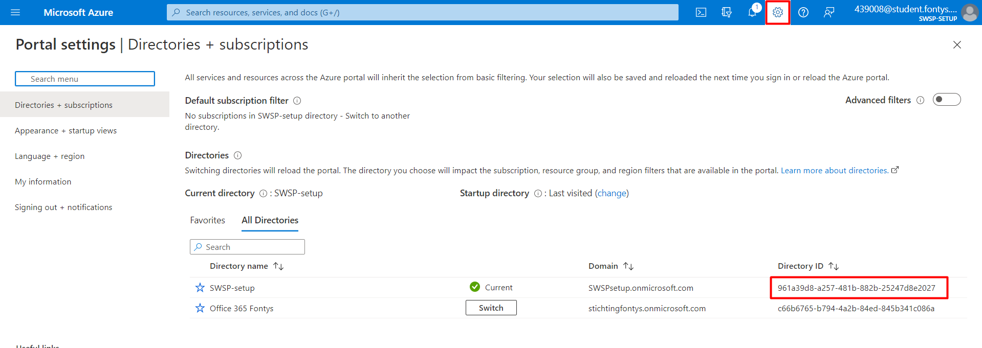

1. Retrieve the Client ID by navigating to App Registrations.

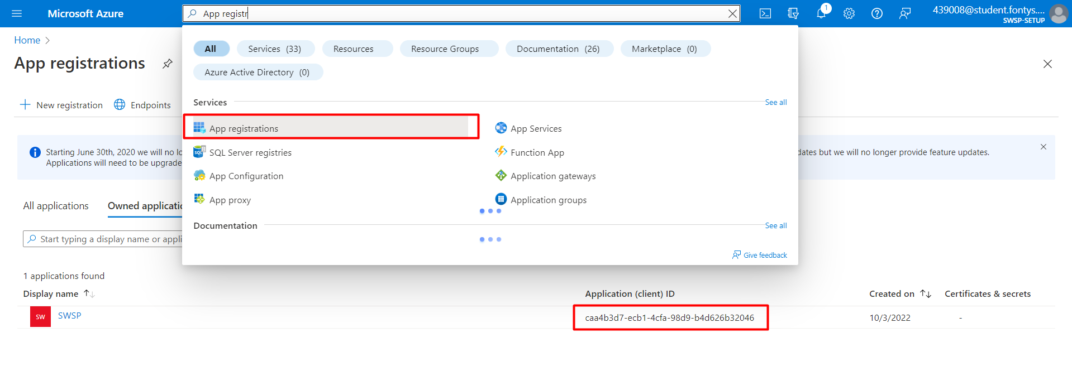

1. Create and save a Secret Value by navigating to SWSP.  
     
   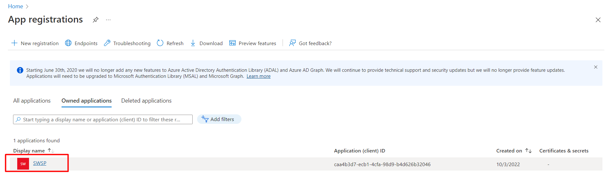  
   1. Click on Certificates & secrets.  
        
      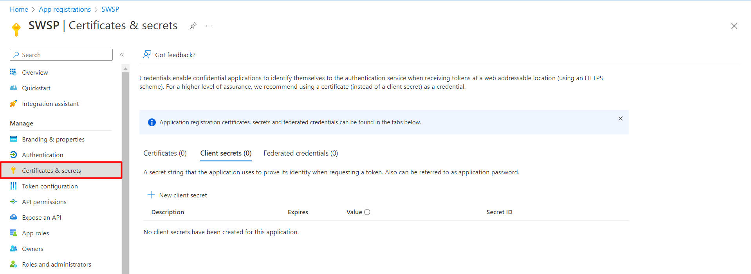
   2. New Client Secret.  
      *Note: The description should be “patient-group-service”.*  
        
      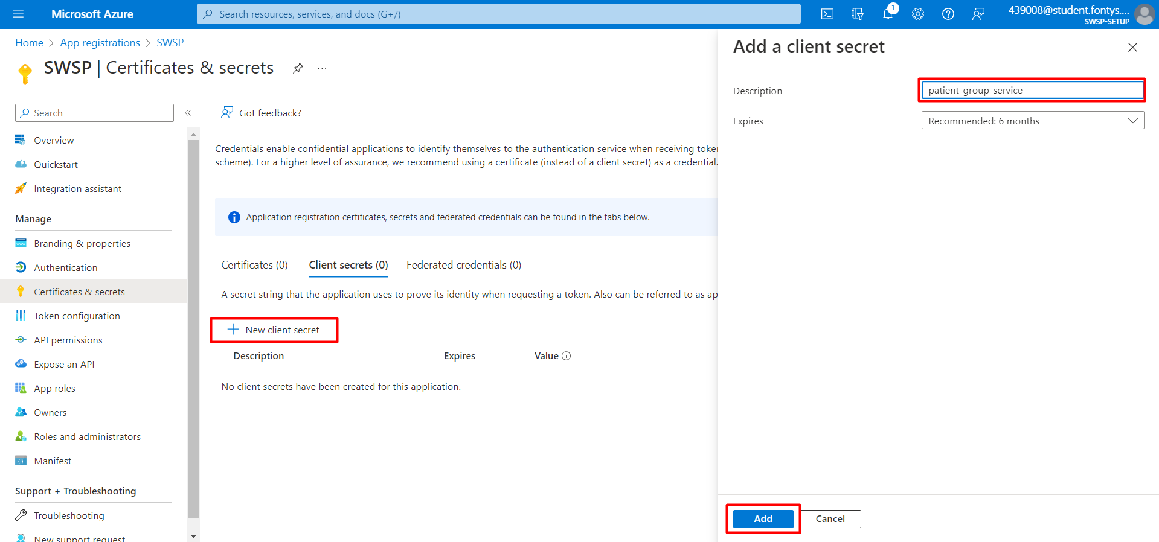
   3. Copy and save the Secret Value.  
        
      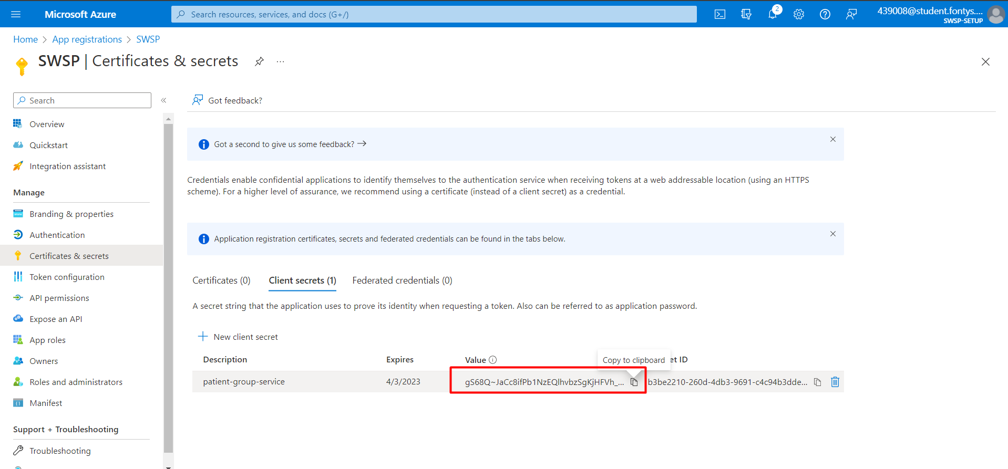
2. Retrieve the caregiver scope by navigating to Expose an API and copying the caregiver value.  
   *Note: The value should equal api://[Client ID] /access_as_caregiver*  
     
   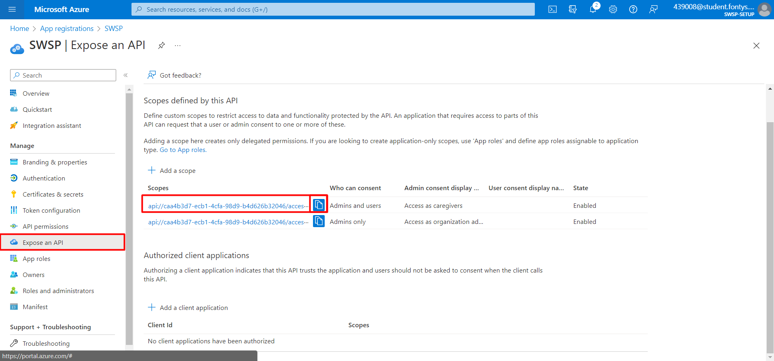
3. Retrieve the caregiver Role ID by navigating to App Roles.  
     
   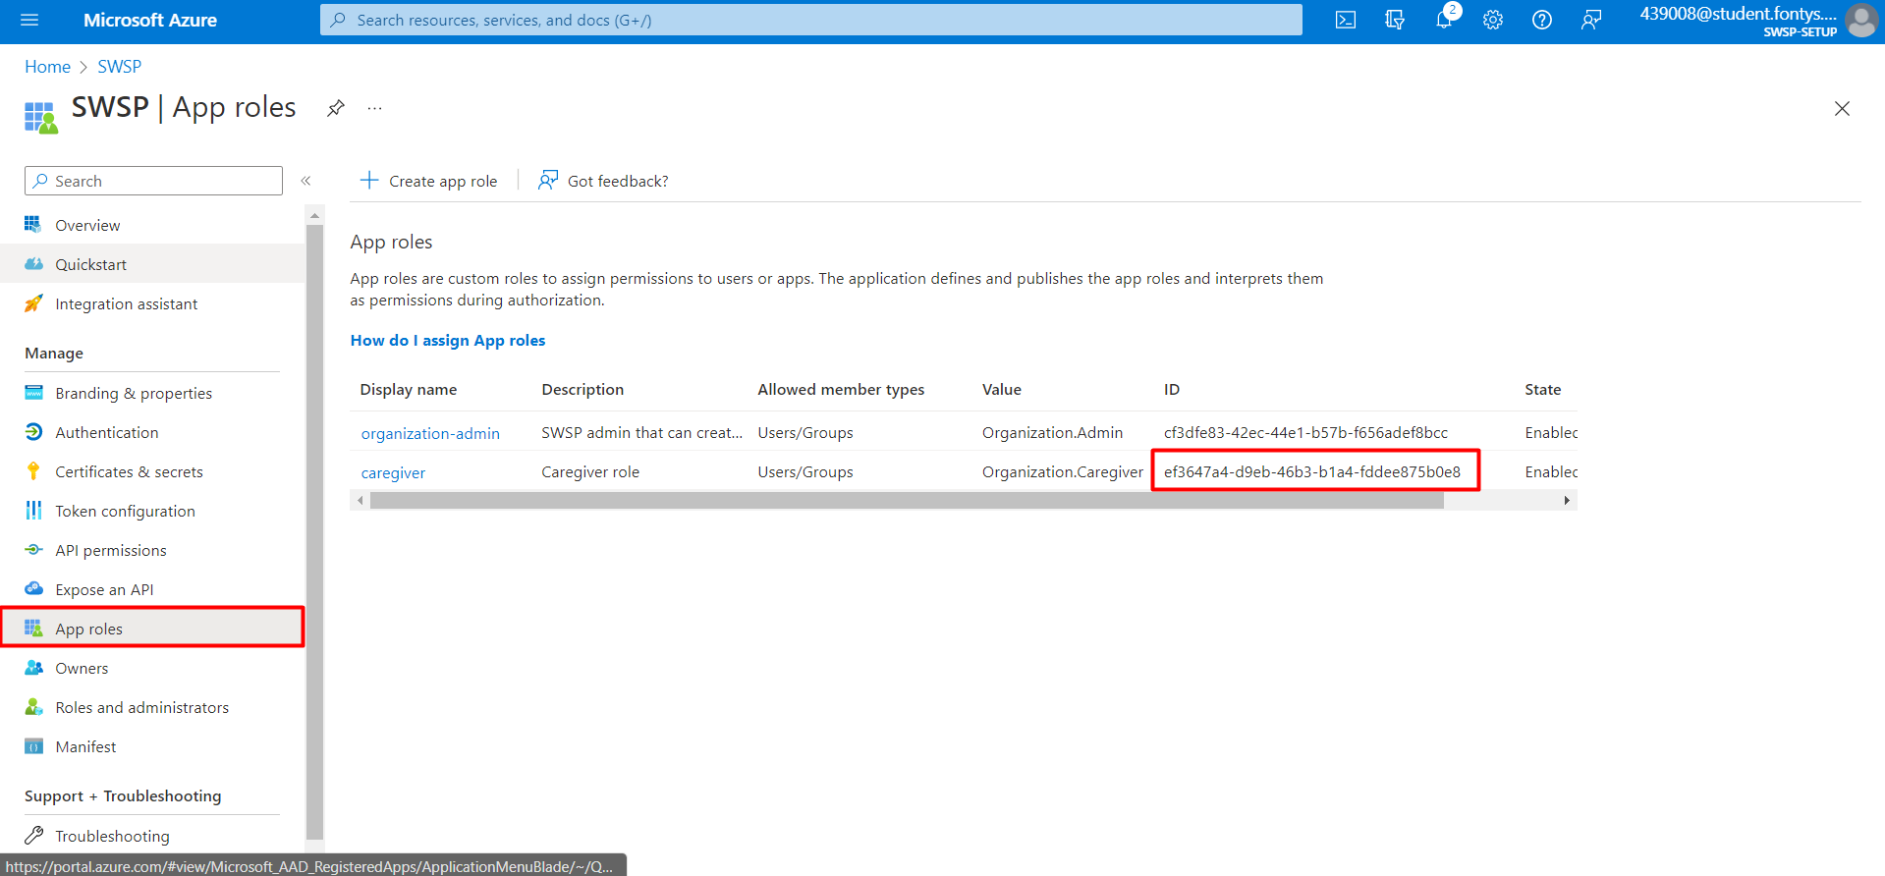

# Modifying Environment Variables

To launch the project successfully, it is necessary to update the .env variables of the SWSP-Infrastructure branch.

1. The TENANT_ID is retrieved in step 37.
2. The AZURE_CLIENT_ID is retrieved in step 38.
3. The AZURE_CLIENT_SECRET is retrieved 39.
4. The AZURE_GRAPH_SCOPE is retrieved in step 40.

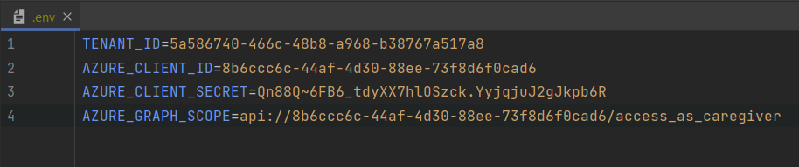

## Service Variables

Local branches have variables stores as well for when they are launched separately. For services, these variables are stored in appsettings.json and occasionally launchsettings.json.

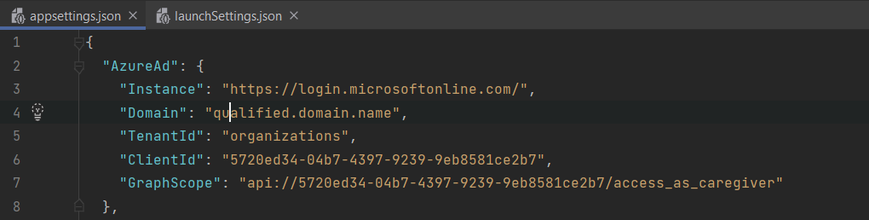

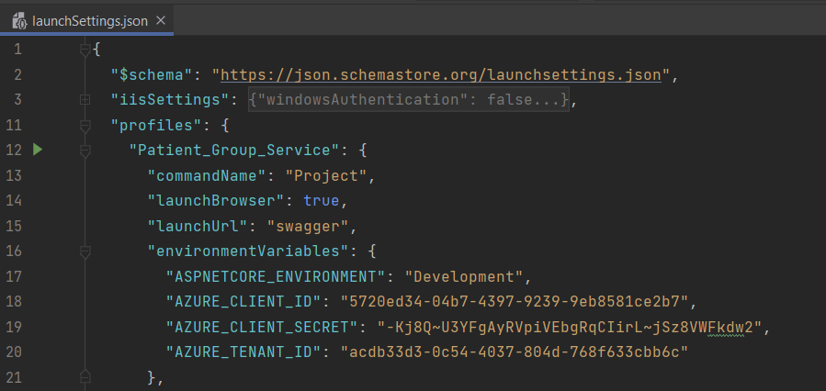

## Dashboard Variables

The dashboards have variables saved in .env.development and .env.production. These should look as follows.

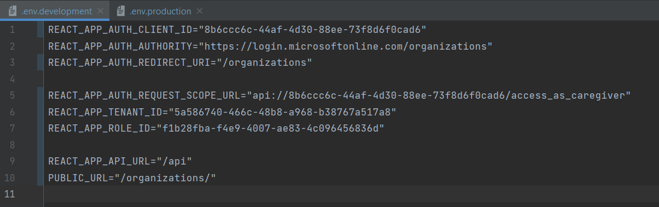

# Creating an Organisation Within Azure

1. Navigate back to [Azure](https://portal.azure.com/#home) and Azure Active Directory.  
     
   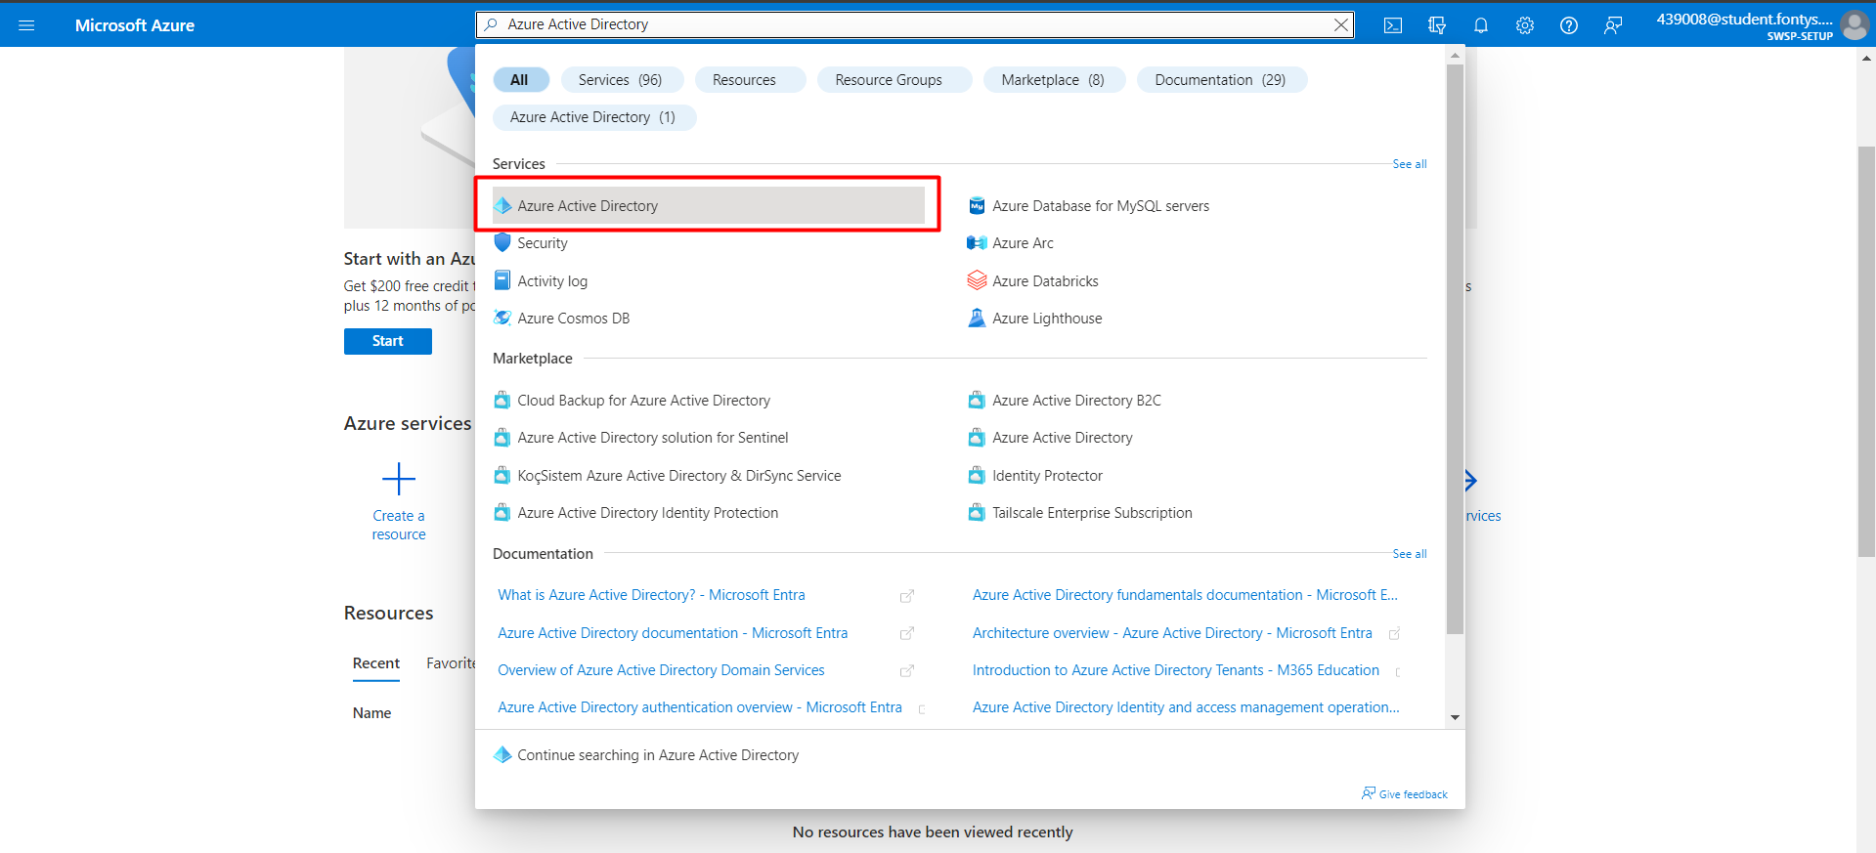
2. Navigate to Manage tenants.  
     
   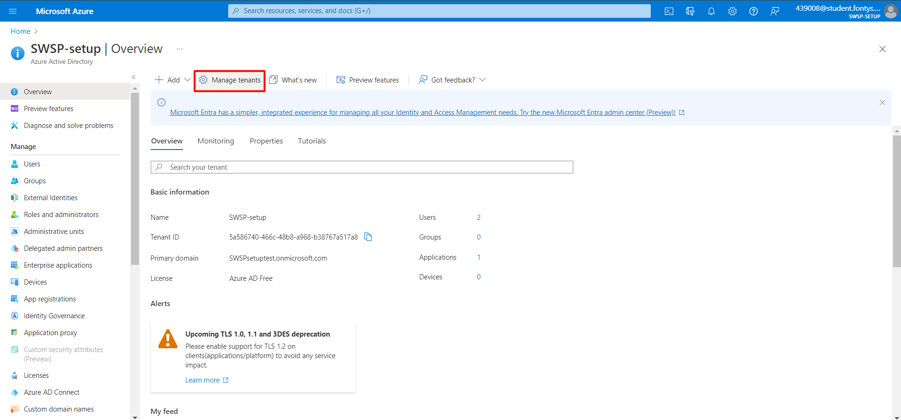
3. Create a new tenant.  
     
   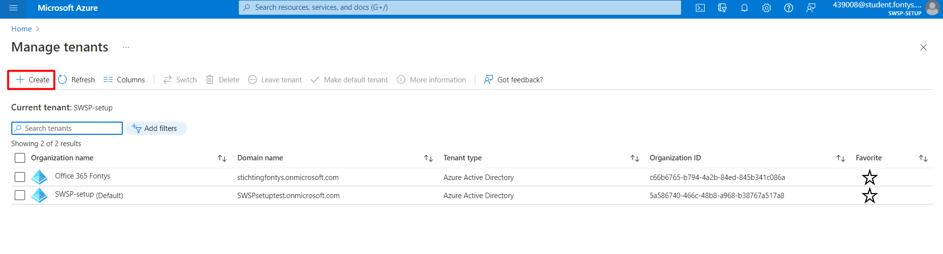
4. Configure and create the tenant.  
   *Note: Confirm you’re not a robot. The creation will take a few minutes*  
     
   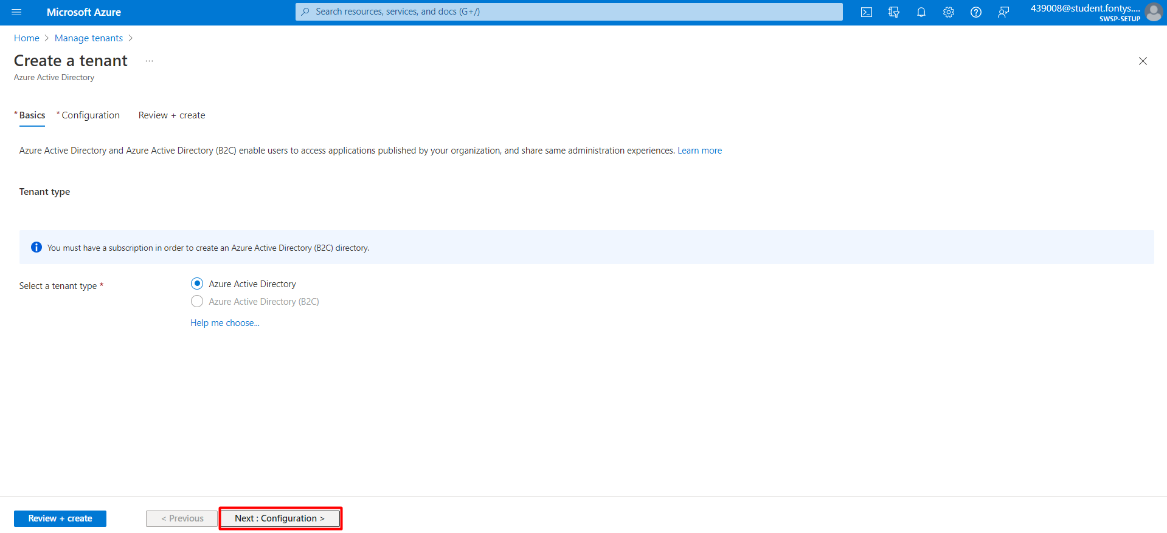  
     
   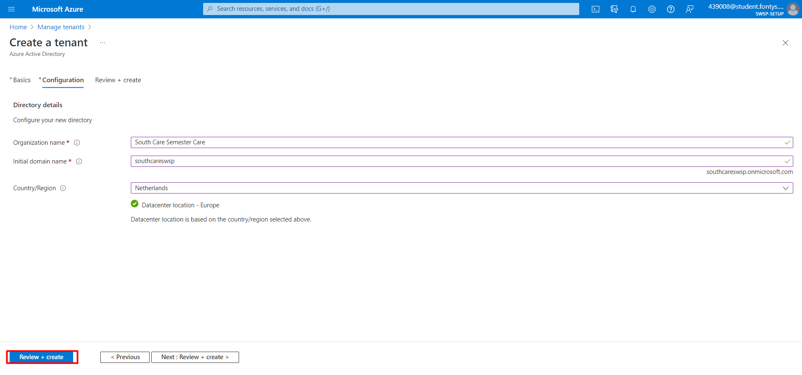  
     
   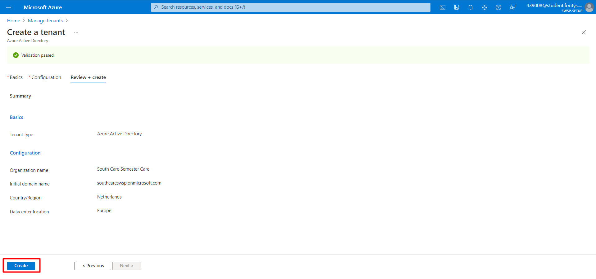
5. Navigate to the tenant.  
     
   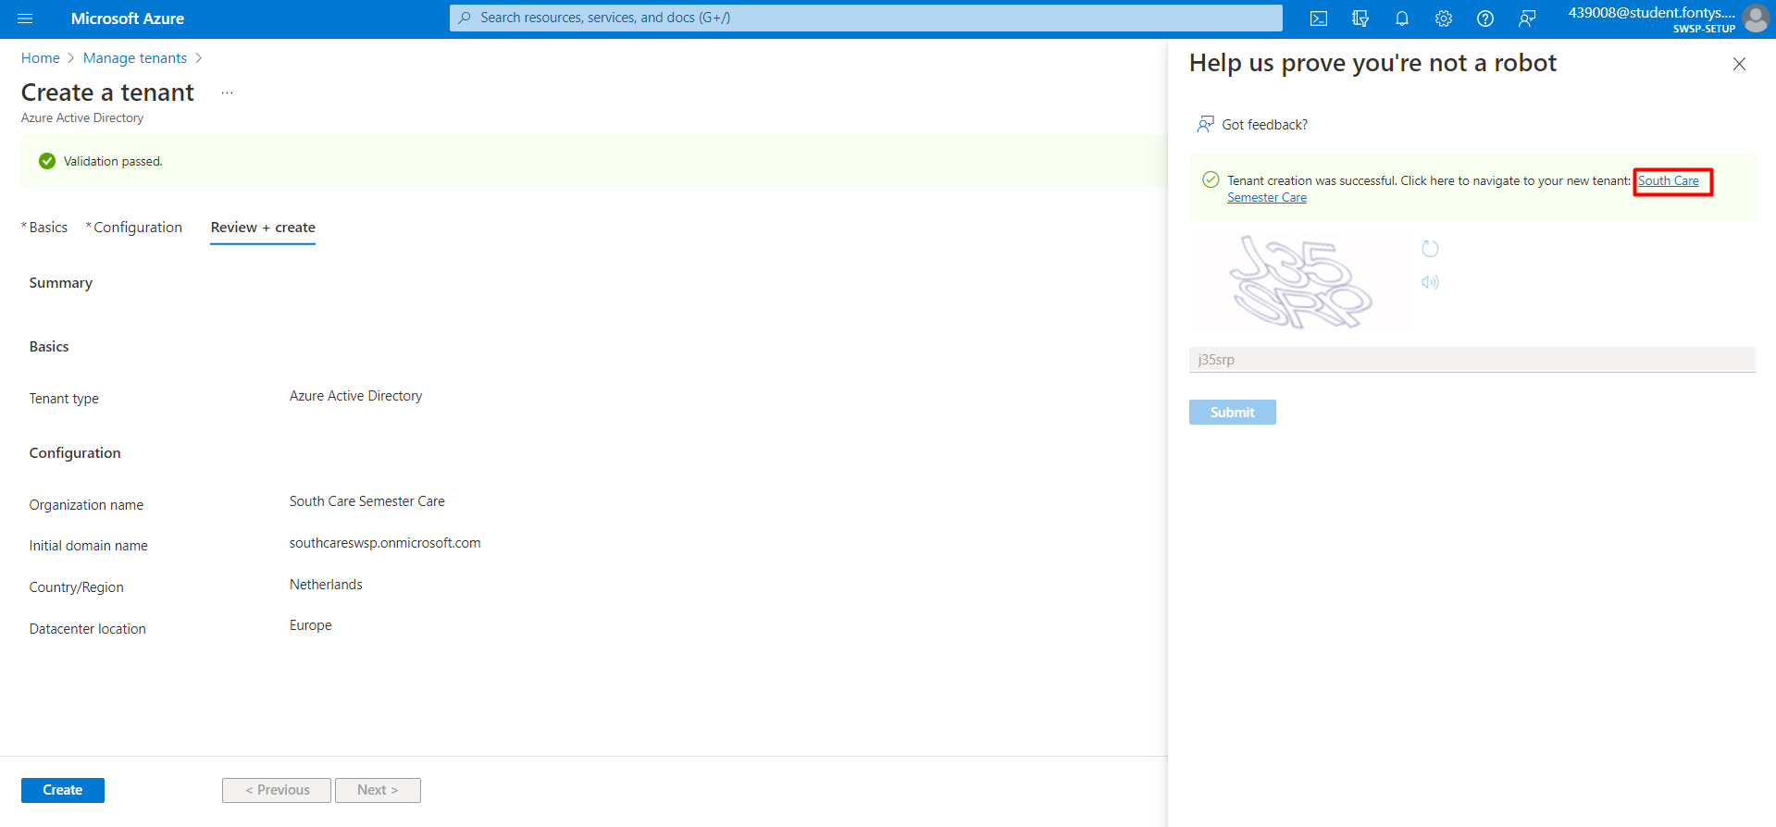
6. Retrieve the Tenant ID.  
     
   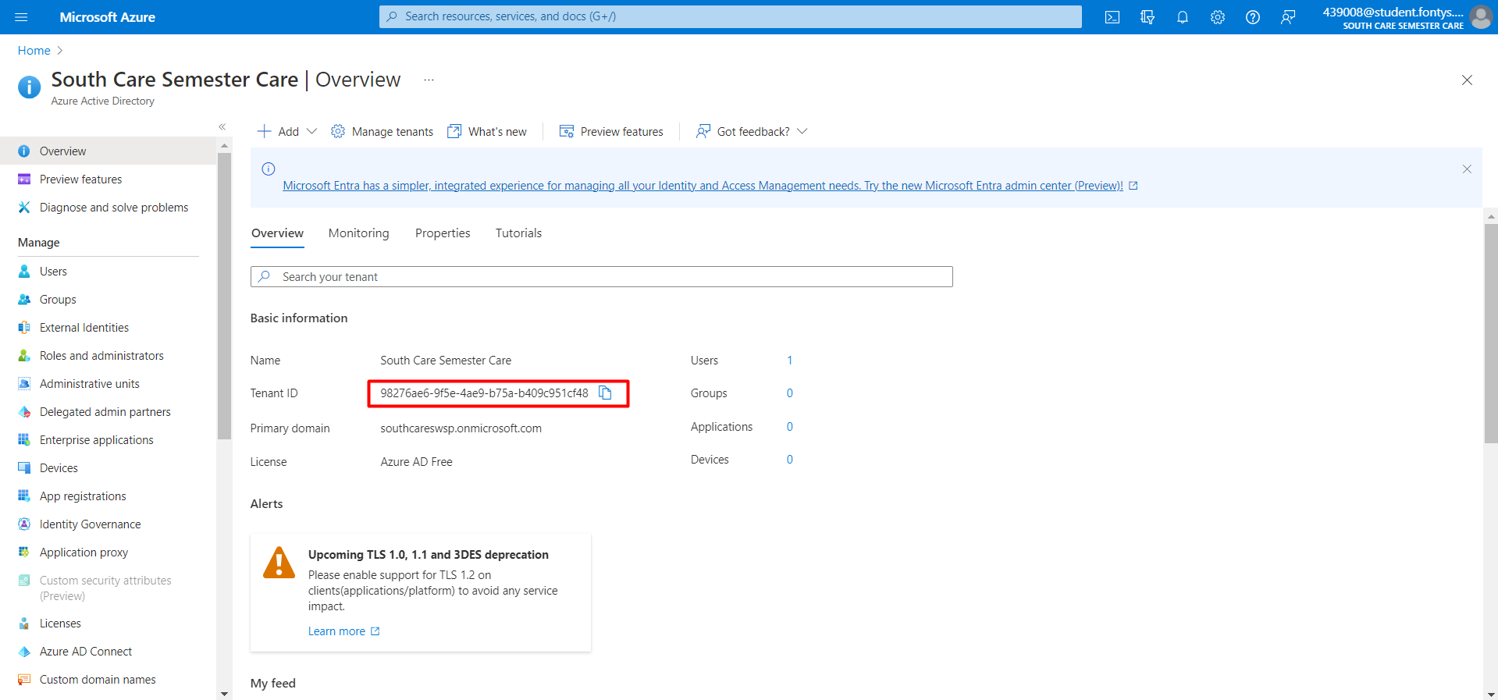
7. Launch the application through the SWSP Infrastructure branch using the command docker compose up. Navigate to the Organisation dashboard located at <http://localhost:3030/organizations>. This will prompt you to log in.   
   *Note: Use the account and password retrieved in step 25 of chapter 2.*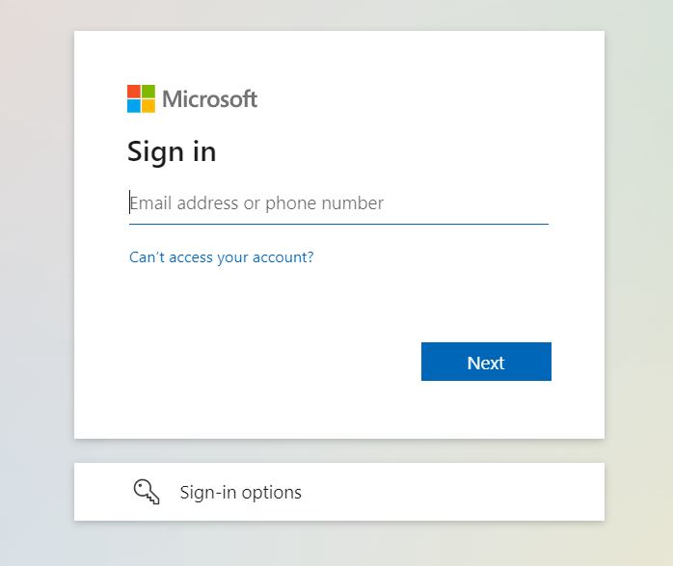
8. Add the organisation.   
   *Note: Make sure the Tenant ID matches that of step 6.*  
     
   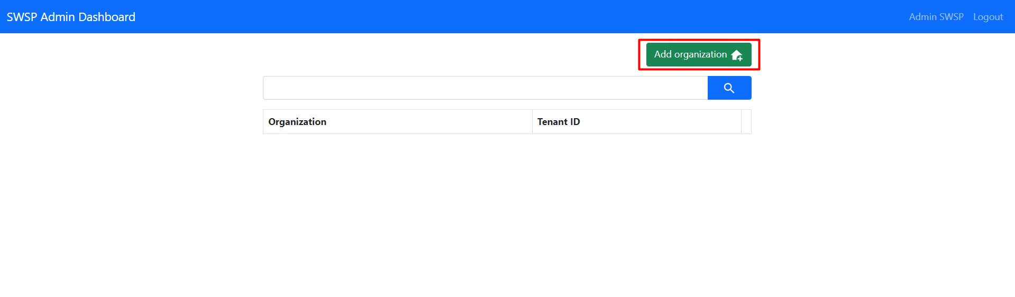  
     
   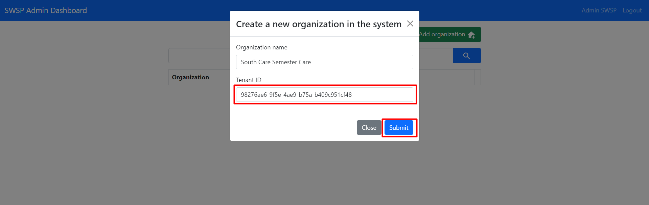
9. If everything went well, this should be the result.  
     
   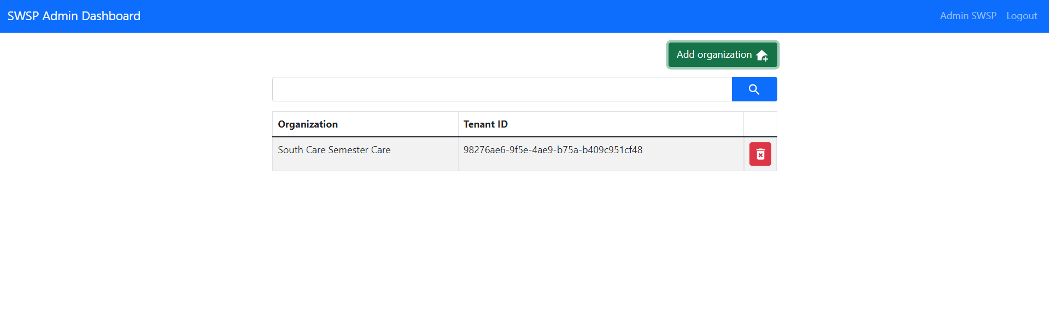

## Creating Users for The New Organisation

1. Add a new user.  
     
   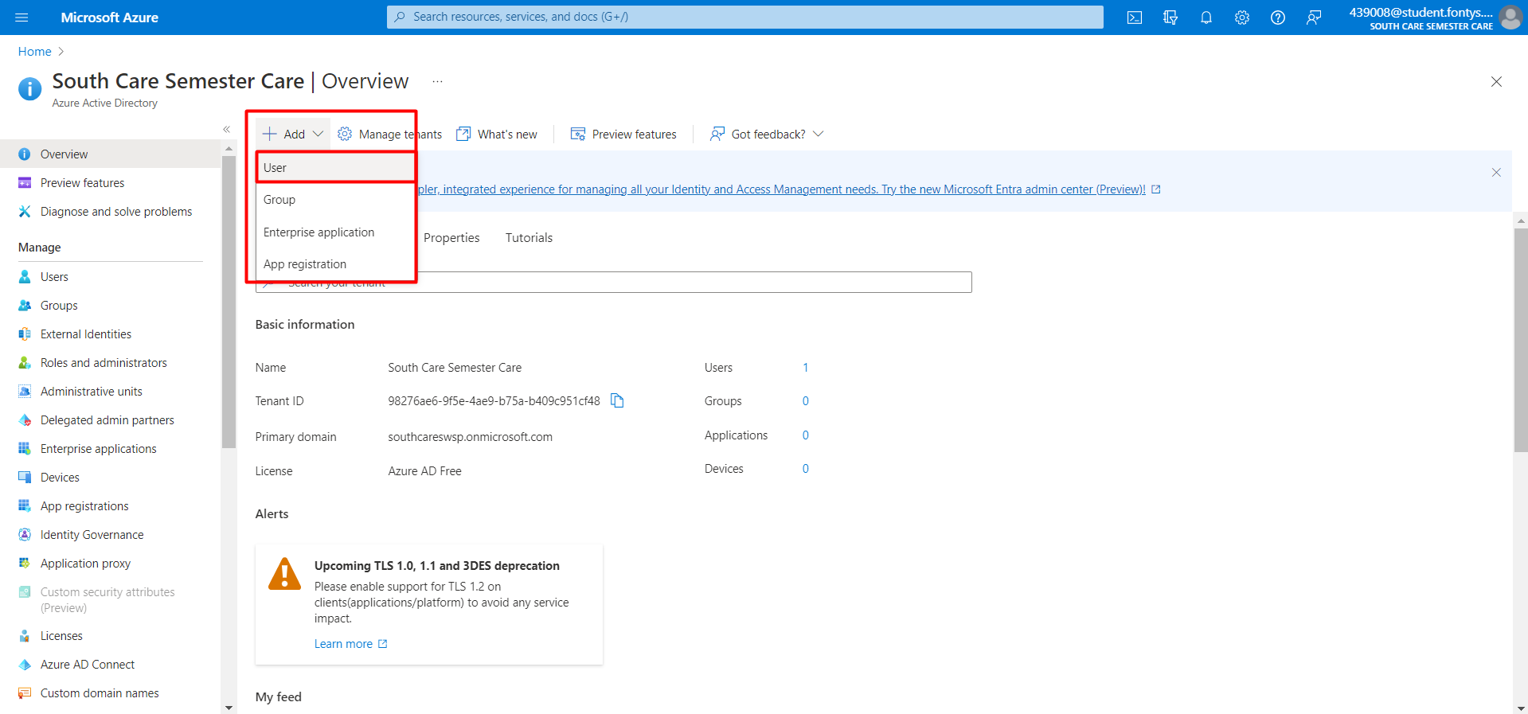
2. Create an admin account.  
   *Note: Write down the account username and password.*  
   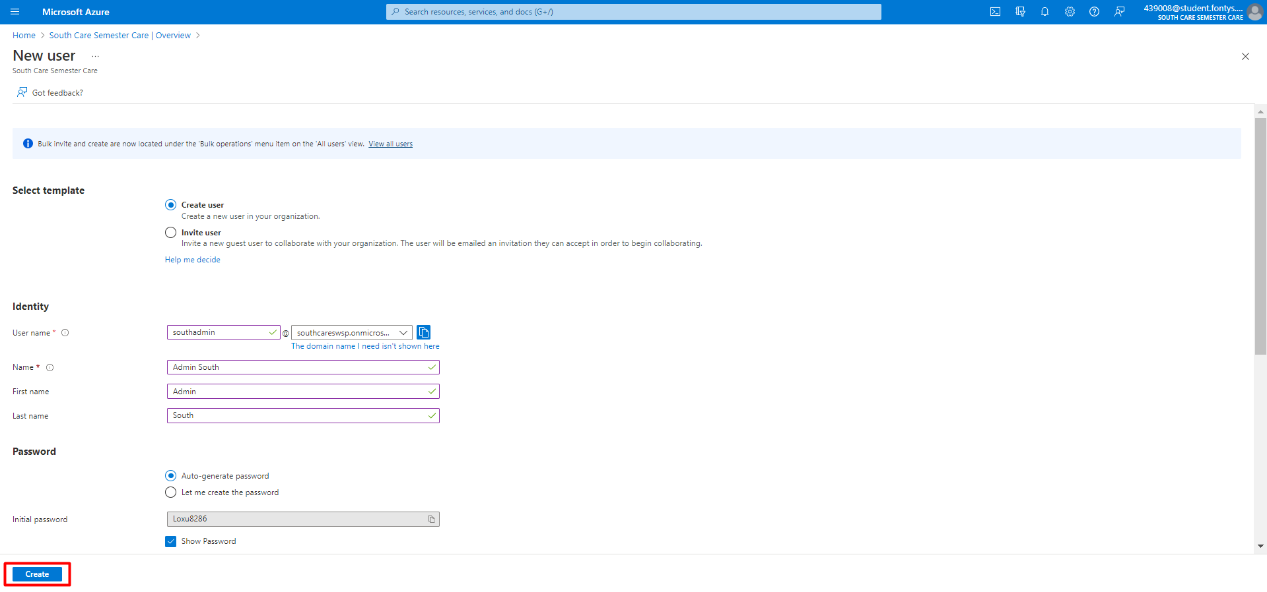
3. Add a user again (step 10) then create a caregiver account.  
   *Note: Write down the account username and password.*  
     
   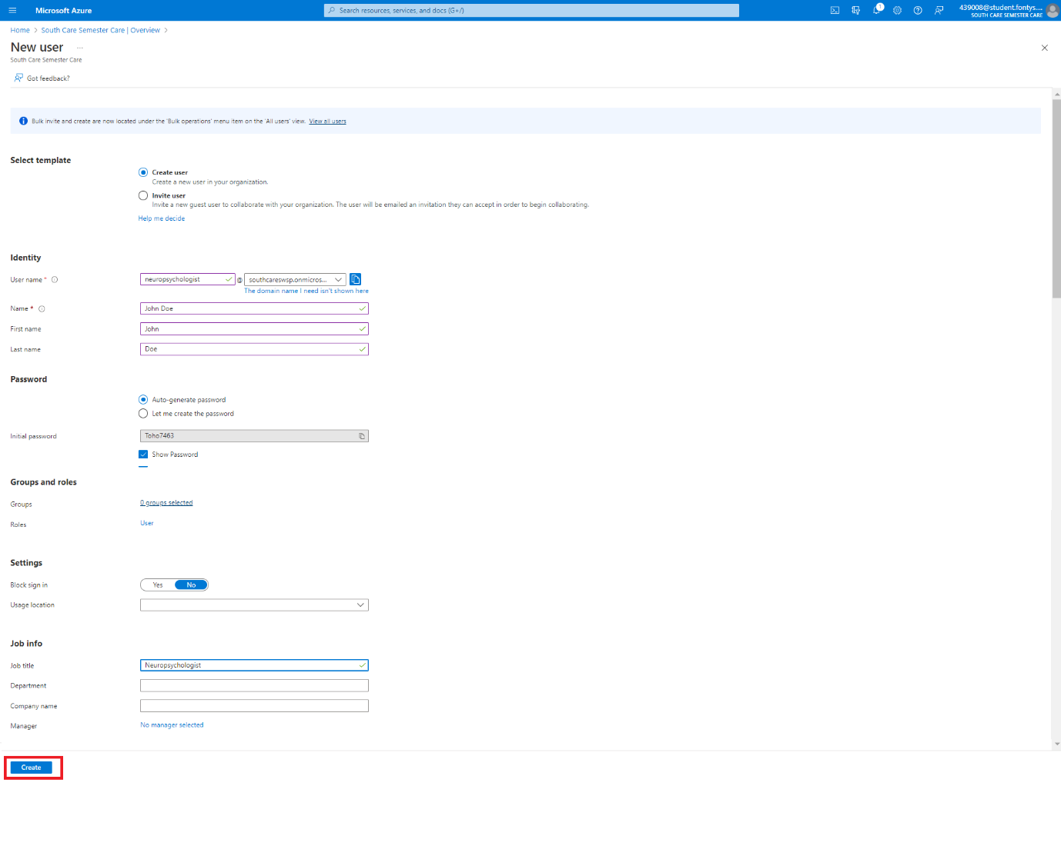
4. Go towards the organisation dashboard. Log in to **both** the admin and caregiver account. This will prompt you to change the password. This is required before changing the role.   
   *Note: You will see the message “You are not authorized to view this page. Please contact your administrator.”*   
     
   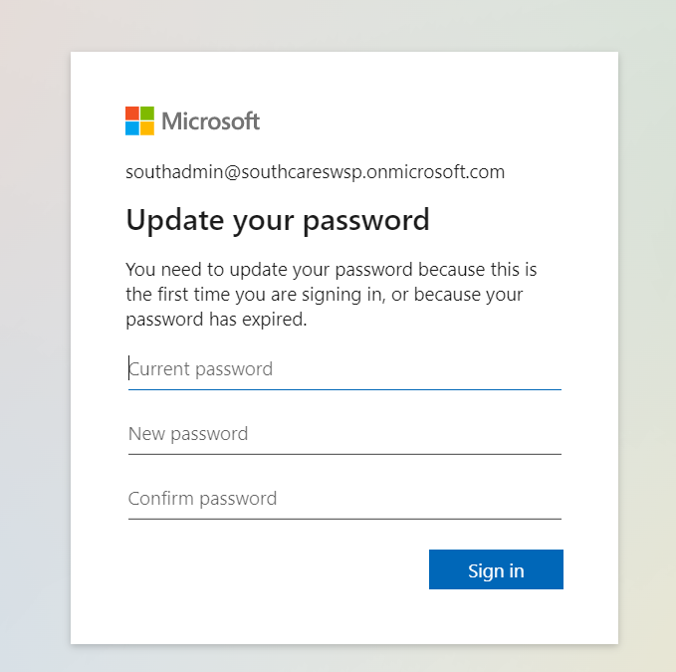
5. Navigate to Enterprise application and SWSP  
     
   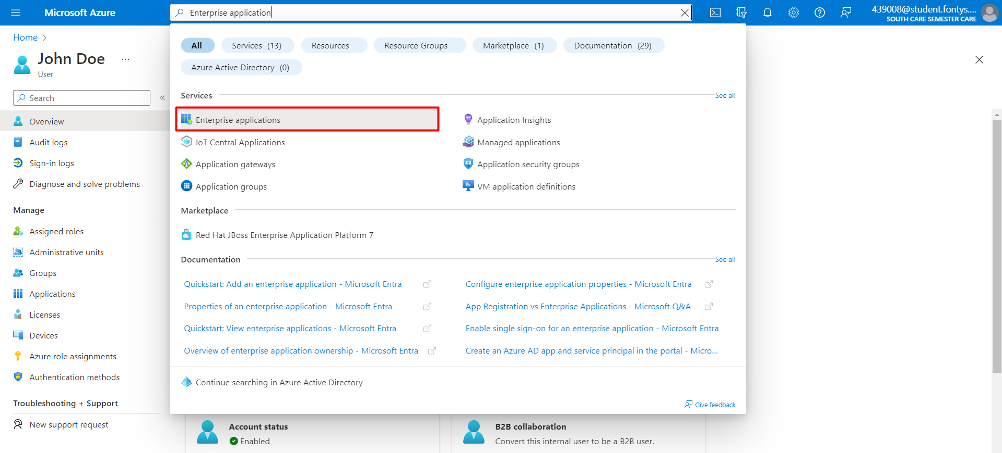  
     
   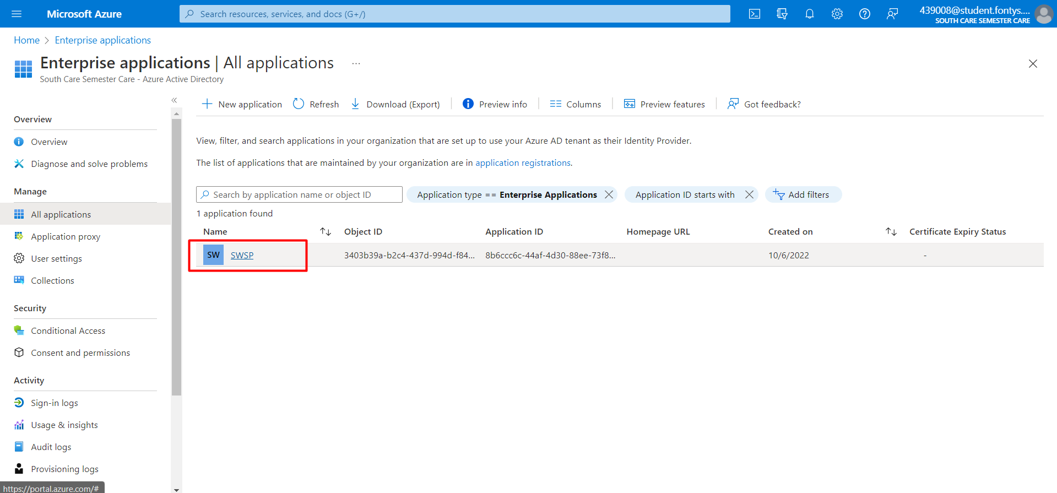
6. Assign users and groups  
     
   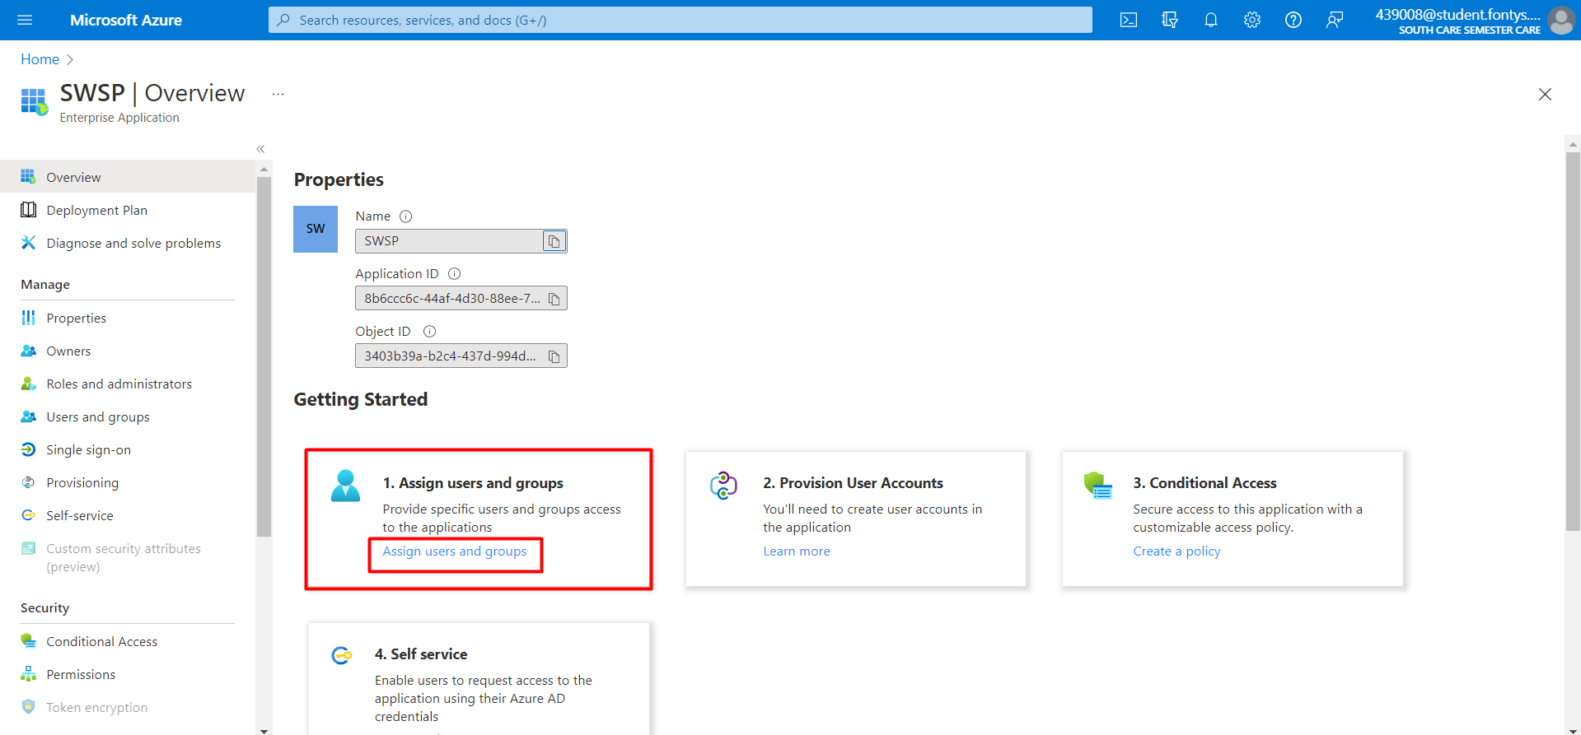
7. Assign the organization-admin role to the admin account and the caregiver role to the caregiver account.  
     
   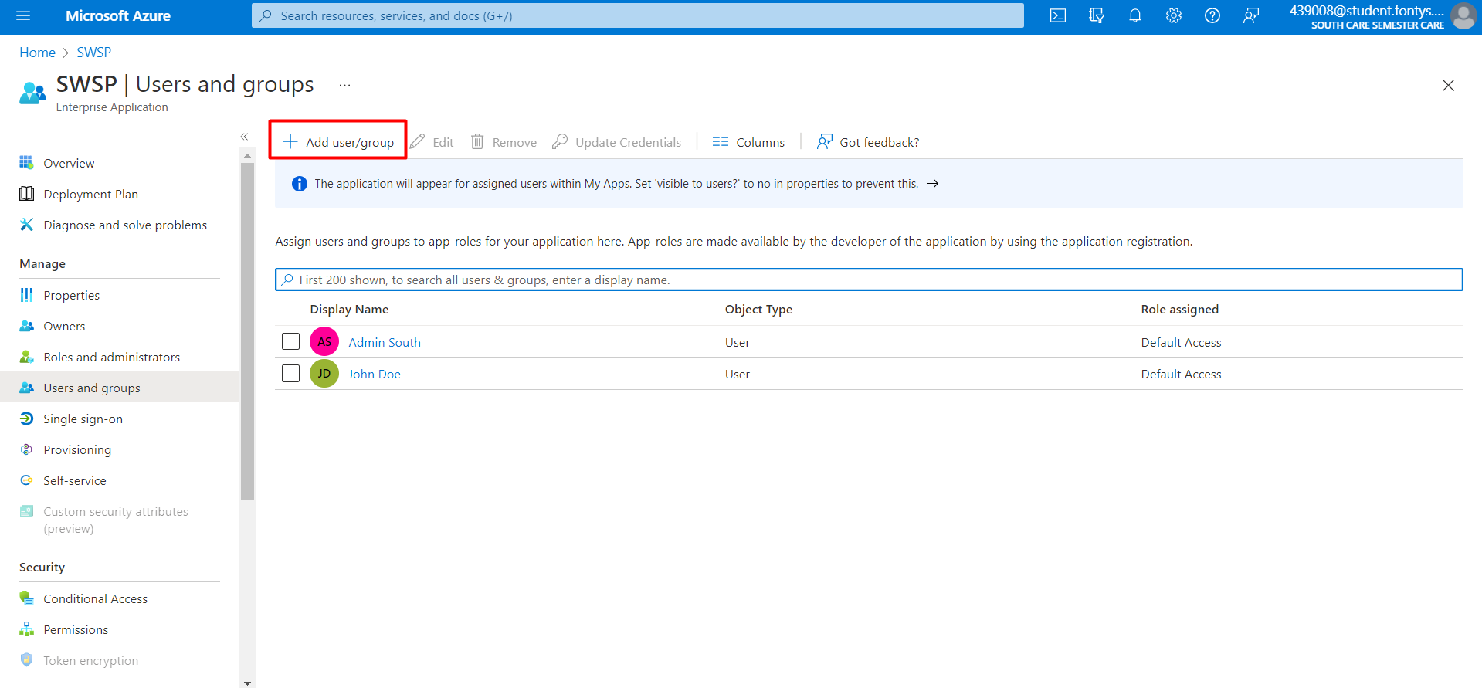  
     
   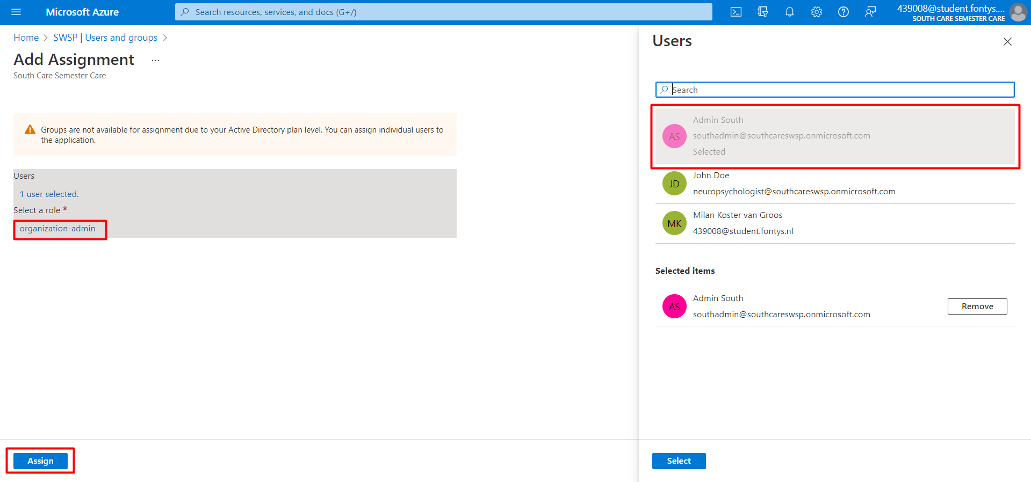  
     
   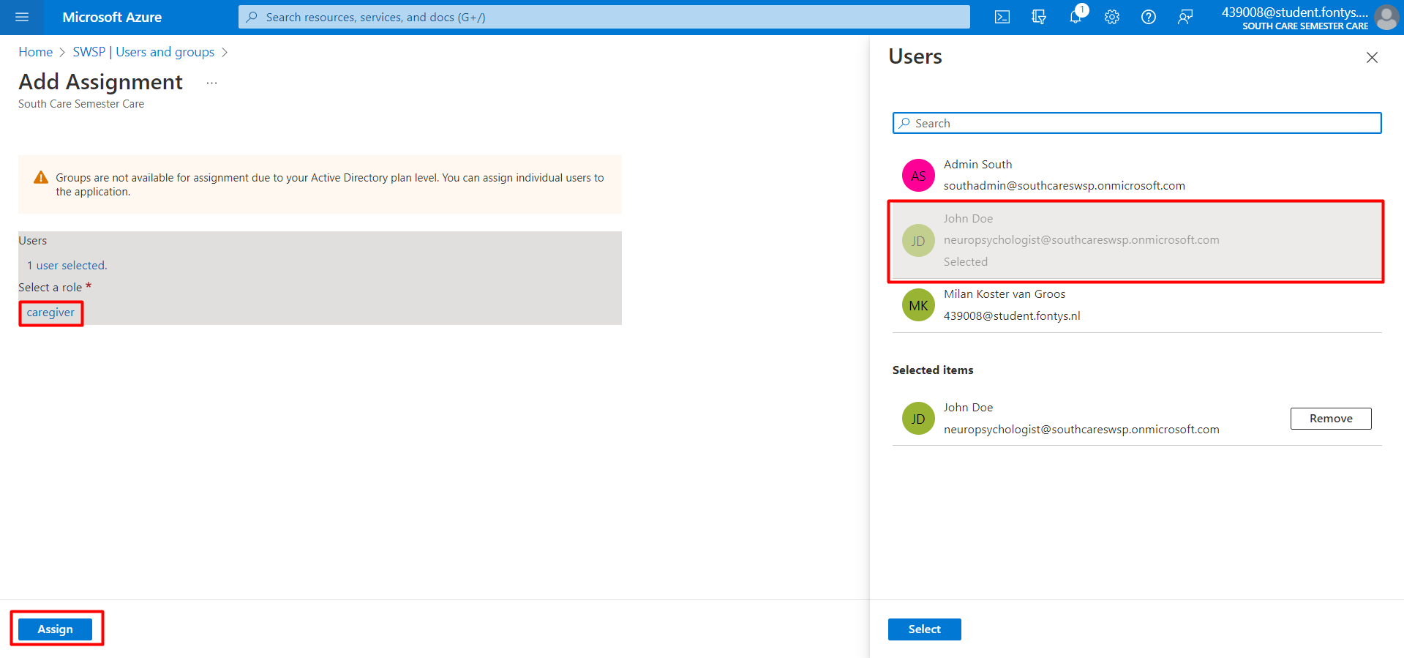
8. If everything went well, this is the result.  
     
   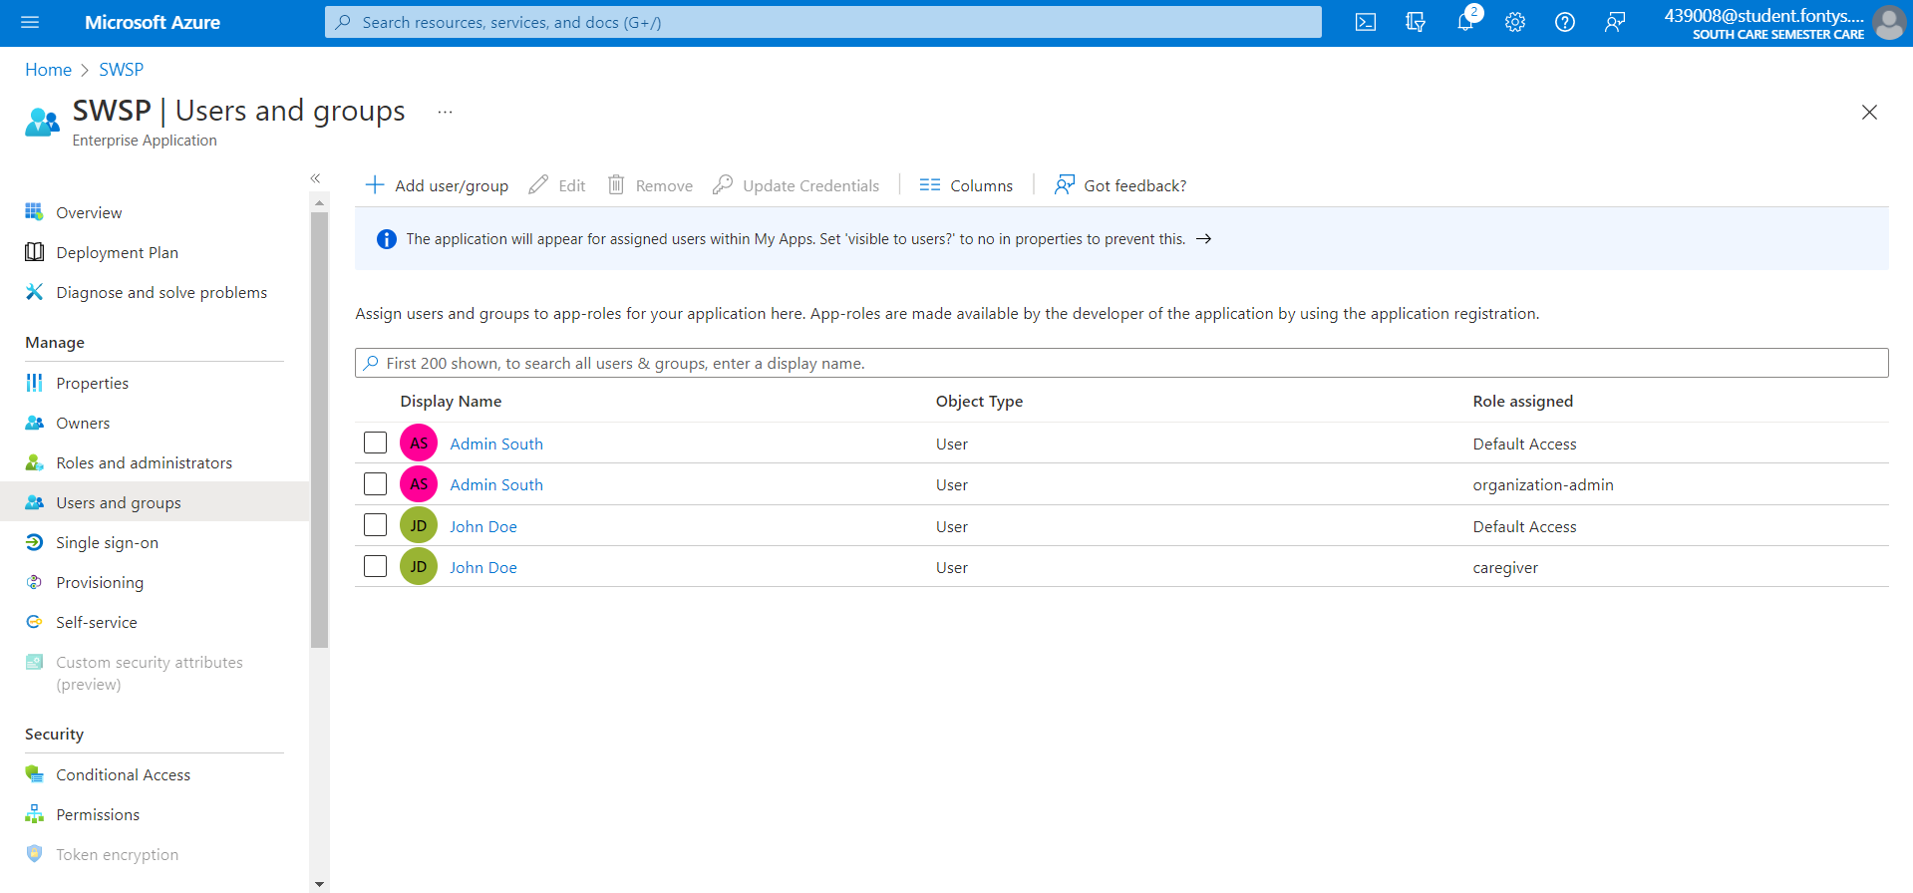

## Grant Permissions

1. Switch back to the SWSP-setup directory.   
     
   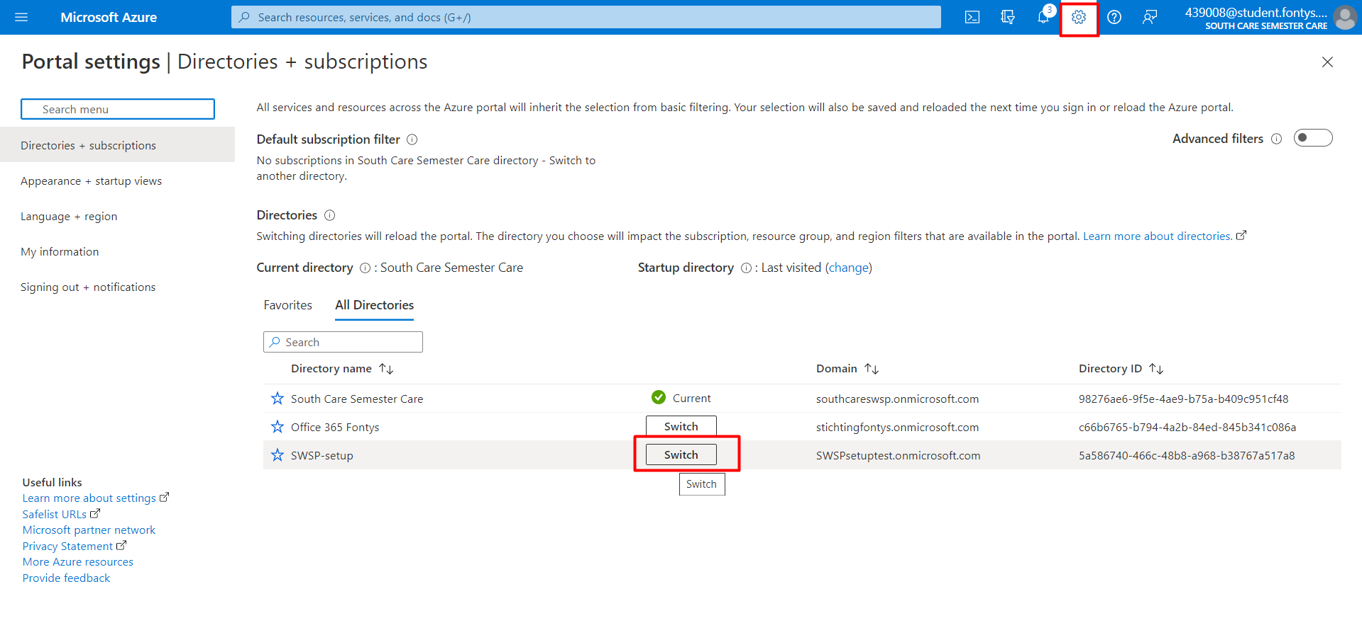
2. Navigate to App registrations.  
     
   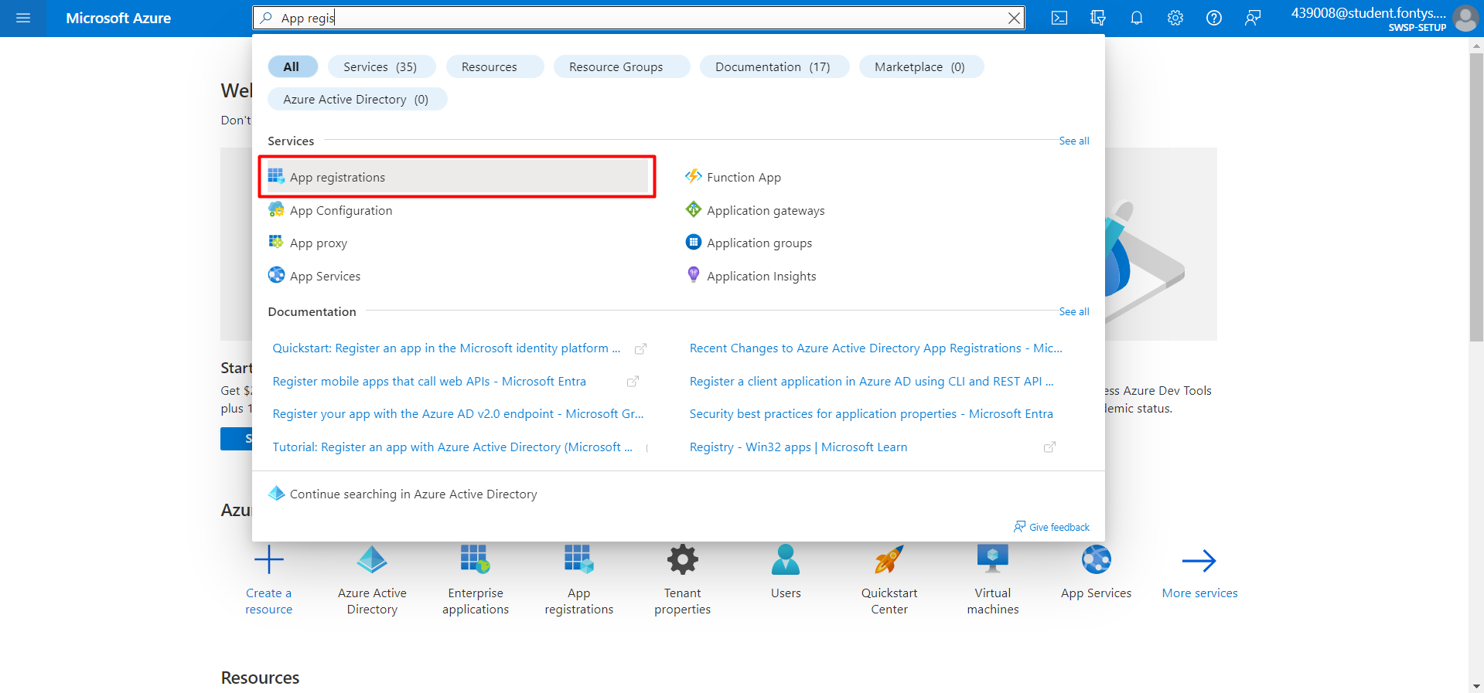
3. Navigate to SWSP.  
     
   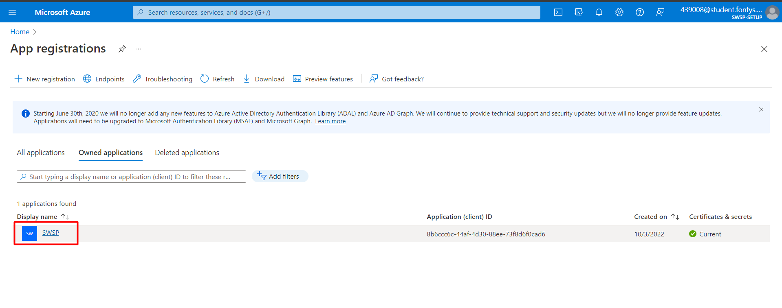
4. Navigate to API Permissions.  
     
   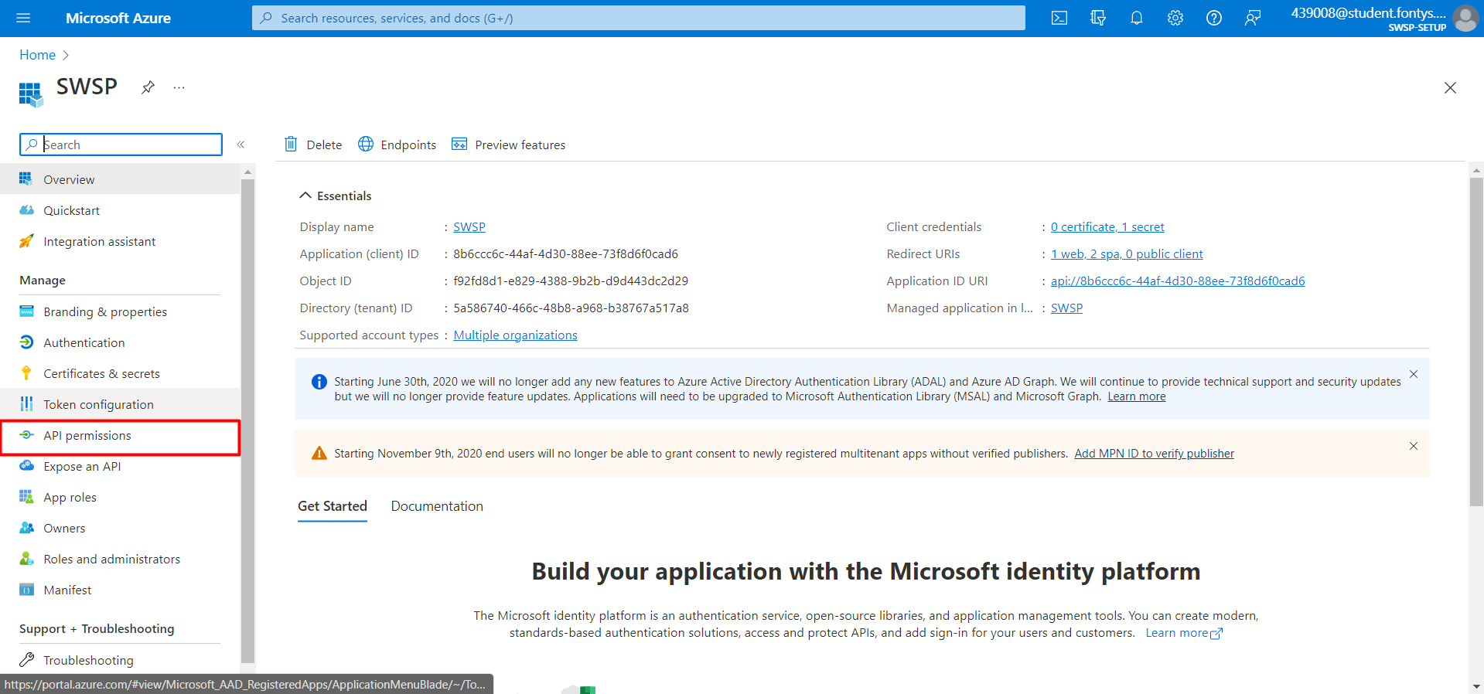
5. Add a permission and select Microsoft Graph.  
     
   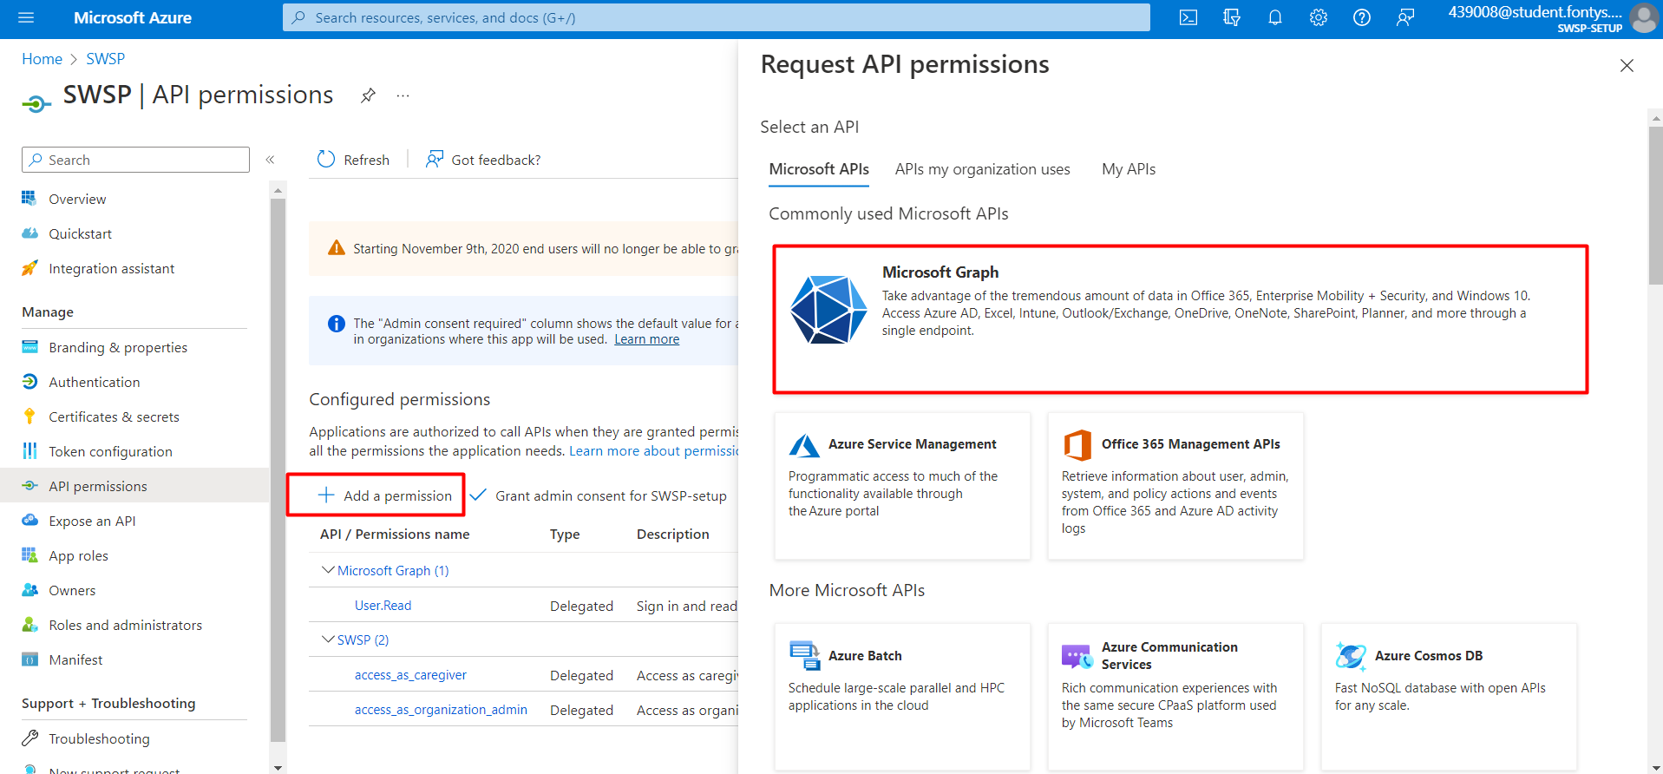
6. Add the following permissions:

|  |  |
| --- | --- |
| **Name** | **Type** |
| email | Delegated |
| profile | Delegated |
| Organization.Read.All | Delegated |
| Directory.Read.All | Delegated |
| People.Read.All | Delegated |
| User.Read.All | Delegated |
| User.Read | Delegated |
| Organization.Read.All | Application |
| User.Read.All | Application |

1. Grant admin consent for SWSP-setup and confirm.  
     
   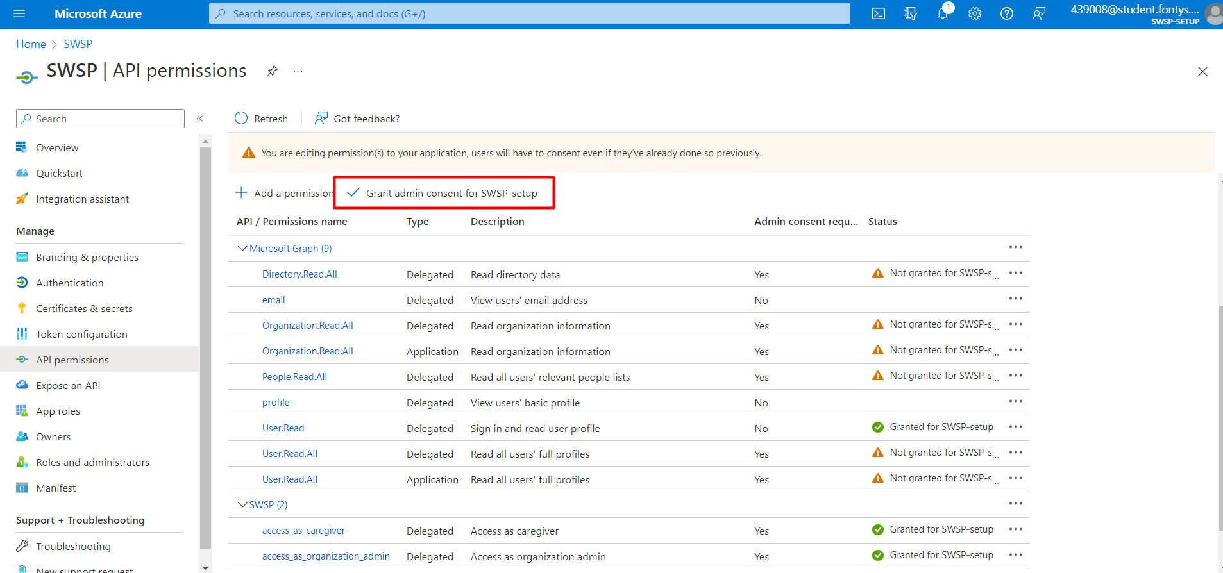
2. This should be the result.  
     
   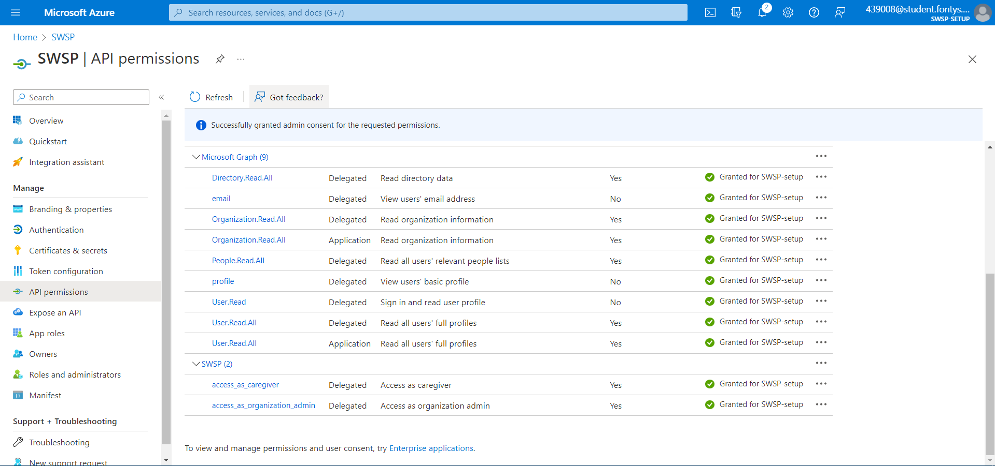
3. Switch back to the newly created organisation (South Care Semester Care).  
     
   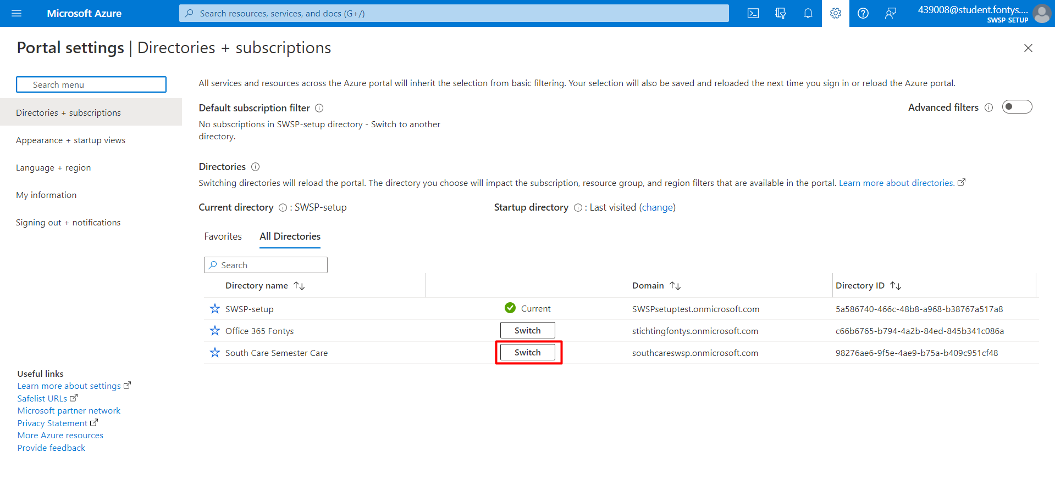
4. Navigate to enterprise application.  
     
   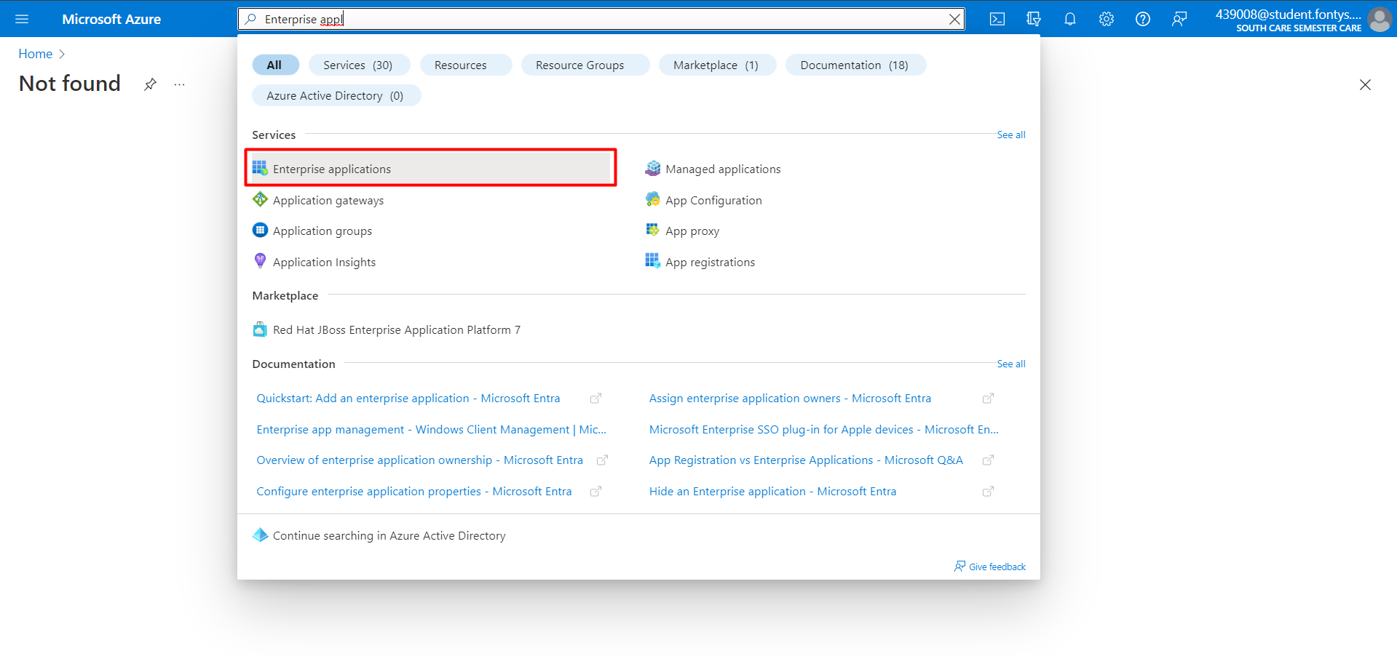
5. Navigate to SWSP.  
     
   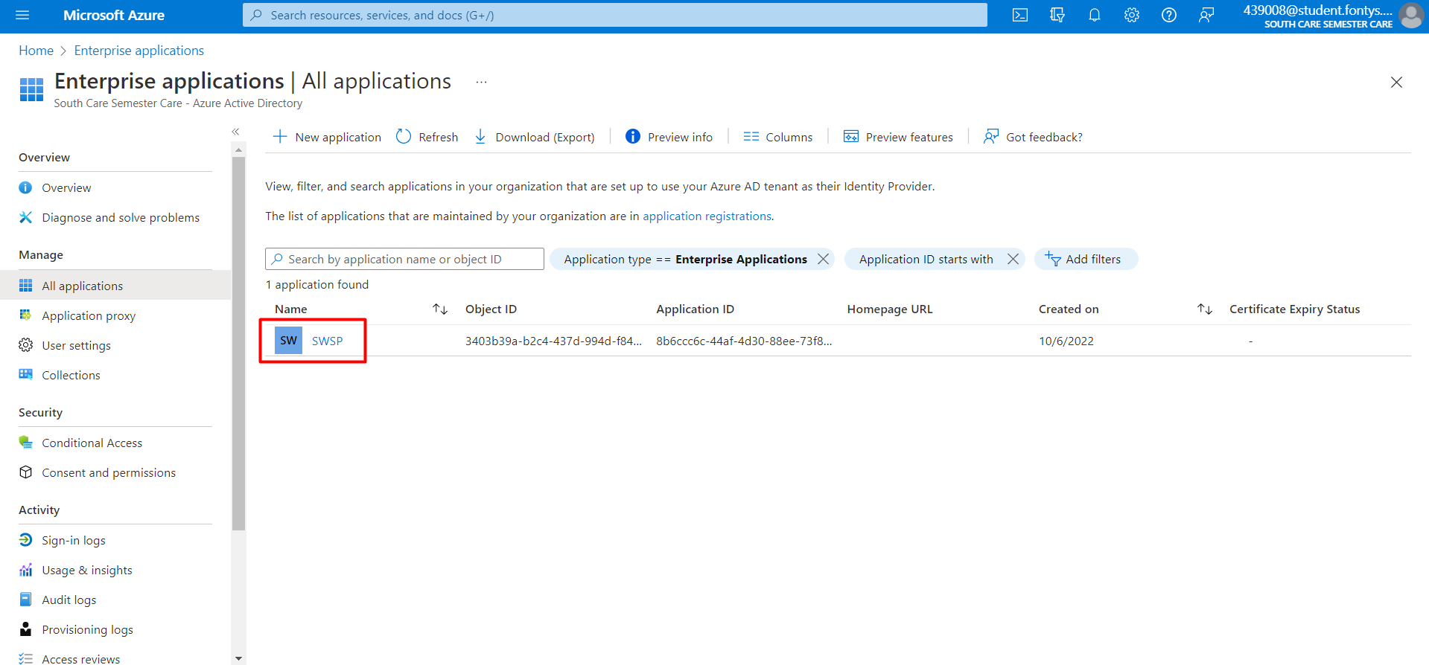
6. Navigate to Permissions.  
     
   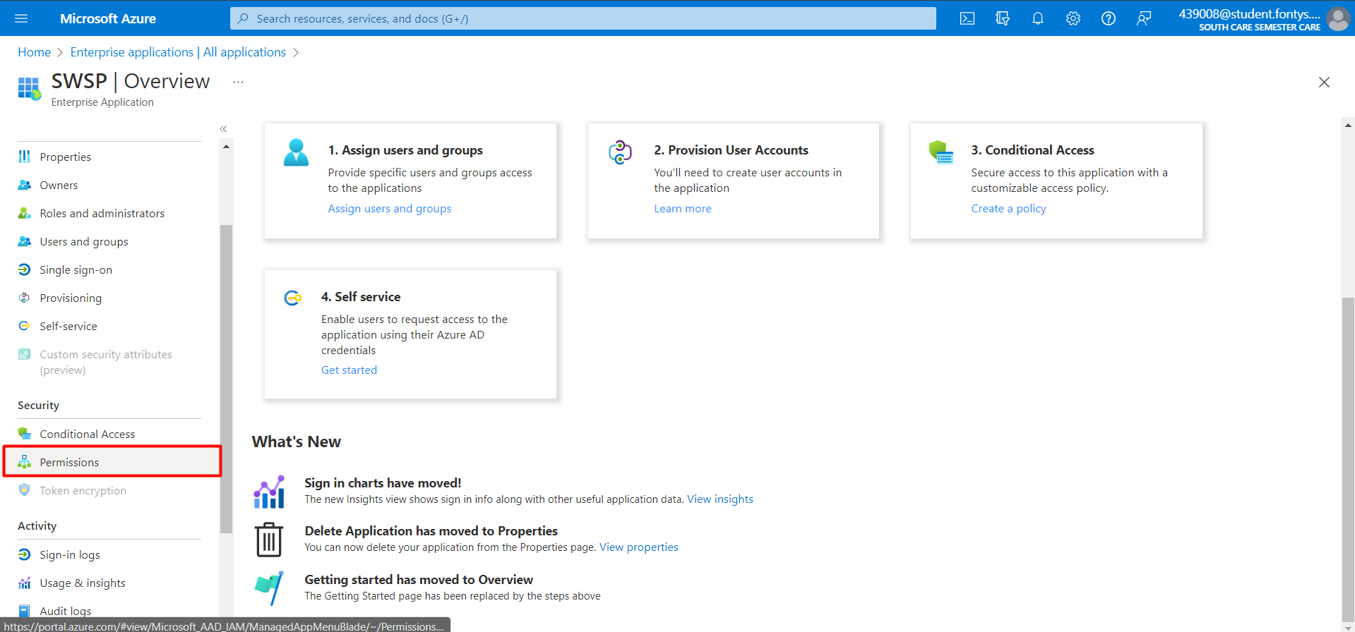
7. Grant admin consent for South Care Semester Care.  
     
   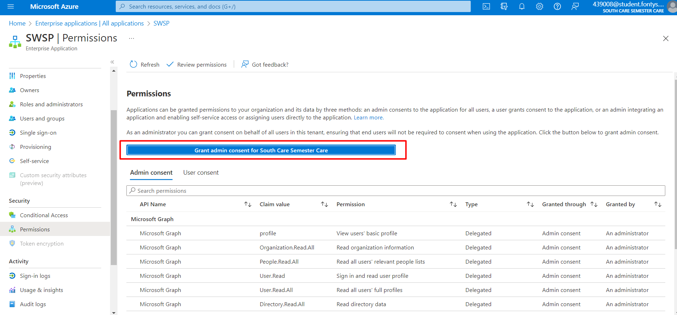
8. It might take a few minutes for this page to update. When complete, this should be the result.  
     
   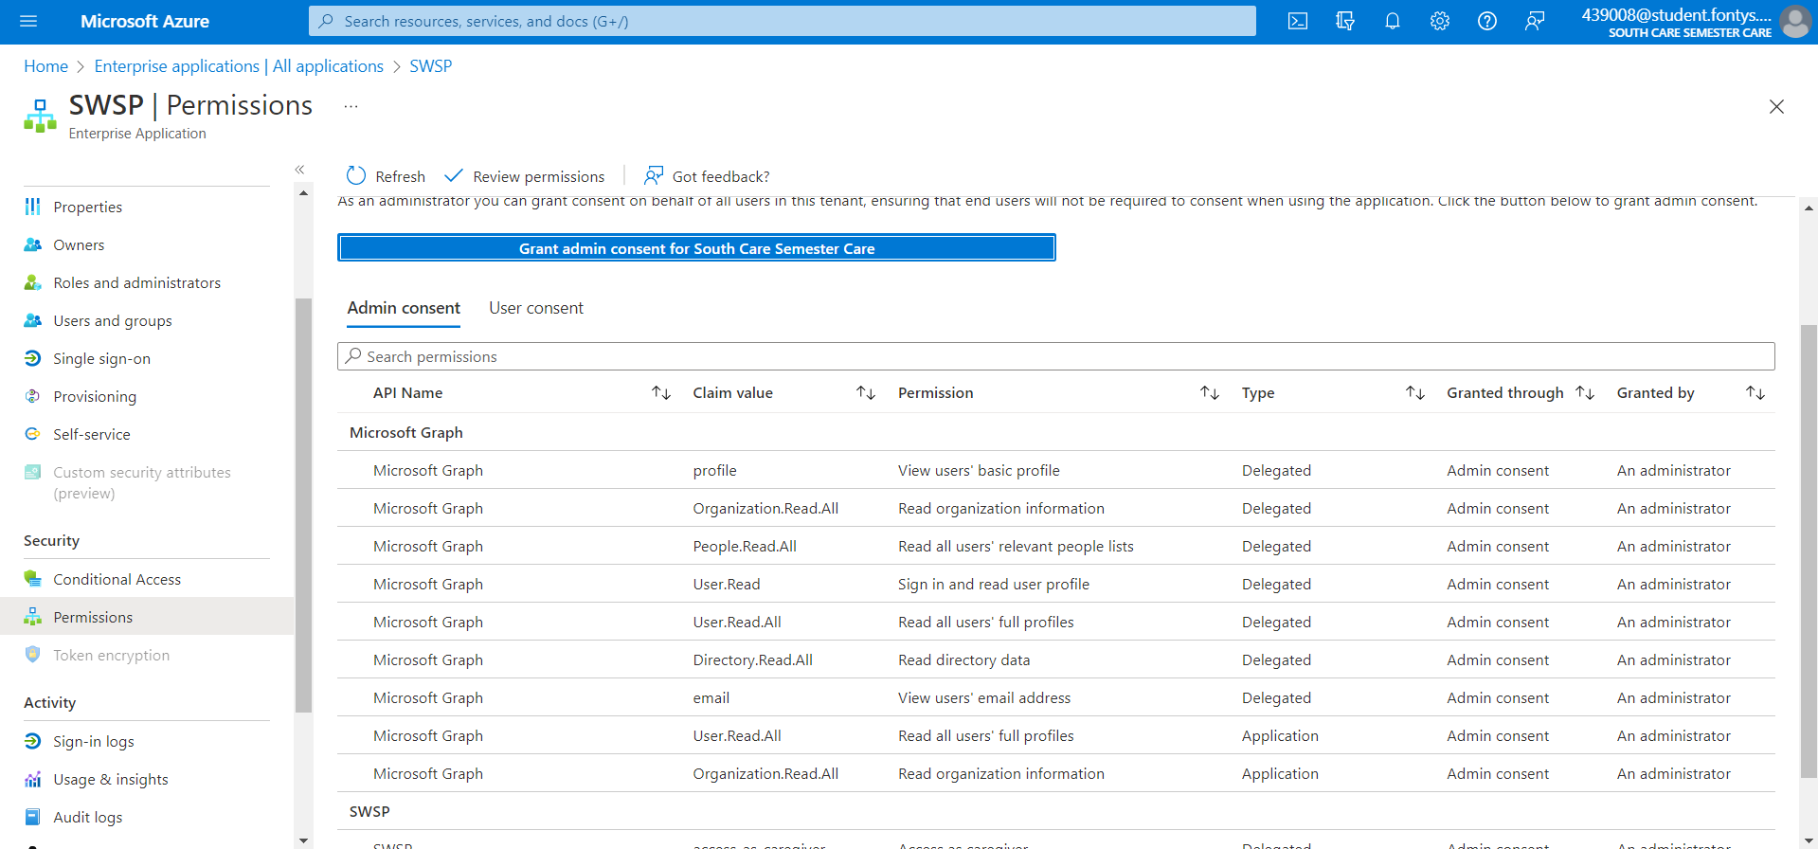
9. You can now use the dashboard with the admin and caregiver account!